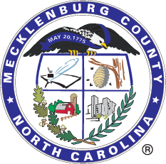

Mecklenburg County, North Carolina
Procurement Division
Solicitation # 487-CM-PID004006

RFP for Online Apparel Storefront
Mecklenburg County, located in the State of North Carolina, is seeking proposals from qualified vendors for the Online Apparel Storefront.

The full solicitation can be viewed at www.meckprocure.com by clicking “Public Access” on the lower left-hand side of the screen.

RFP DUE DATE: No later than 2:00 PM (EST) on Wednesday, October 23, 2024.

RFP NUMBER: #487-CM-PID004006

RFP ACCEPTANCE PLACE: All responses must be submitted by the Due Date in MECKProcure..

Vendors must have a profile with the County to submit a response. For more information on vendor registration and how to submit a response, please visit the Vendor Resources Site here.

Please note that all updates regarding this solicitation will be posted on the above-mentioned website, MECKProcure. To ensure that notifications are received, vendors must create a profile with the County.

If you are a registered vendor with the County and did not receive an email notification about this solicitation, please update your vendor profile to include the NIGP Code(s) listed below so that you receive notice of future business opportunities.

NIGP Code(s): 91548

Sincerely,
Caroline Miller
Procurement Analyst
Caroline.Miller@mecklenburgcountync.gov

