PRE-PROPOSAL and/or BID CONFERENCE/SITE VISIT AGENDA

Proposal/Bid Number: 65-SAO1.0-2024 Description: Study Abroad Office – Pre-approved vendors
Date: October 2, 2024 University of North Carolina – Chapel Hill

Purchasing Agent: Christy Baldridge Phone #: 919-962-8727
Email: cbaldridge@unc.edu

1:50pm | Christy – open zoom
2:00pm | Welcome & Introductions:  Start Zoom recording. Conference call housekeeping: Mute phone line, Use Chat to check-in with host & questions.  @Morgan – monitor chat box & “raised hand” for questions
Central Procurement:
Christy Baldridge, facilitate RFP, meeting notes, Q&A
Study Abroad Office:
Jason Kinnear, Associate Dean of Study Abroad
Christine Trinidad, Senior Director for Programs & Advising
Chrissie Greenberg, Senior Director for Business Operations
Morgan Douglas, Accounting Manager

2:05pm | Christy | Confirm vendors have signed in. Close access at 2:00pm, Review timeline & NC IPS process.
2:10pm | Christy | Bid summary, highlights from statement of work.  RFP links - Summary page of the individual forms -> https://www.doa.nc.gov/divisions/purchase-contract/vendor-forms
2:30pm | All | Open Q&A discussion
3:00pm | Christy | Review any follow up action items  - Written questions due by end of day 02-Oct  - Answers & meeting notes posted on eVP by 04-Oct, 3pm  - Proposals are due 18-Oct, 3pm ET
3:30pm | Christy | Close & stop recording

Bid Timeline Update:

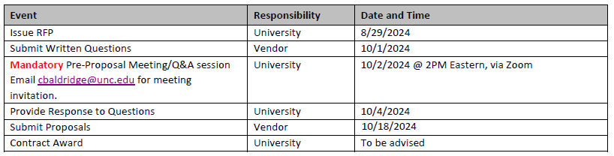

https://evp.nc.gov/solicitations/
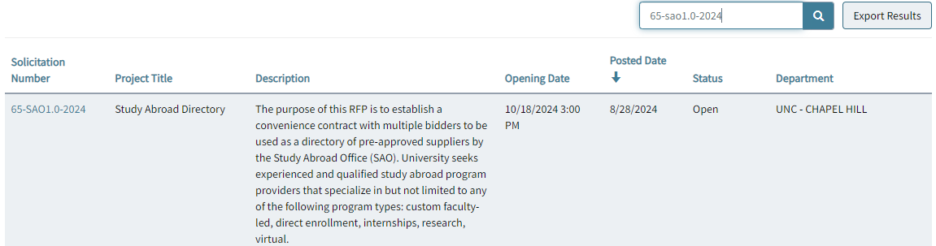

 | Question: | Answer:
1 | RFP links to attachments are broken, provide alternate. | Summary page of the individual forms -> https://www.doa.nc.gov/divisions/purchase-contract/vendor-forms
2 | What are the EXECUTION PAGES from the proposal qualifications?  (RFP 2.8 Proposal contents, page 8) | See RFP intro prior to table of contents.
3 | Section: ATTACHMENT A: PRICING, page 22  Pricing discounts Attachment A:  - Please define “Published Price Discount” and “Program Discount”. What are the differences between these two discount fields?  - Please define UNC’s expectations in terms of pricing discounts. | Format example:  Published Price Discount – %  Program Discounts – are any offered?  Expectation:  - Explain the pricing model/methodology  - For example, are discounts offered on volume, advance purchase, scholarships.  For this RFP, Attachment A is intended to capture the pricing methodology. It is understood, it is too soon to give a program price.
4 | Section: 4.5: VENDOR EXPERIENCE, page 12  Resume: How many are expected and what specific information should be included? | Concise & relevant.  Who are the key points of contact?  FYI - Peer group institutions = https://oira.unc.edu/oira/unc-system-defined-peer-group/
5 | Section: 5.3: Questions to Vendor, pages 18-19  - What answer length (maximum or minimum word count) should our responses be for section 5.3: Qualifications of Vendor? | Concise & relevant.

6 | Section: 5.3: Questions to Vendor, pages 18-19  - We have specific questions for items in section 5.3: Qualifications of Vendor:  Can you share more information about what is expected for #4 Geographic Expertise and Resources: Please highlight any particular areas of geographic/regional expertise on your programs?  Does Attachment A cover this response or should we share a longer form answer describing each of our sites and expertise? | Encourage a brief descriptive answer.  It is acceptable to include links to your corporate policy or referral to full list in attachment A
7 | Section: 5.3: Questions to Vendor, pages 18-19  For some of these questions, like #7 and #10, we could attach or link to the CET policy documents and CET Plan for Overseas Emergencies directly. Or is a longer form answer summarizing these CET documents preferred? | Encourage a brief descriptive answer.  It is acceptable to include links to your corporate policy or refer to full list in attachment A
8 | For question #16 for Custom program samples, CET has a long history of partnering with UNC on customized and faculty-led programs. Do these samples need to be five non-UNC samples? Or can we integrate several examples of past CET-UNC custom program collaborations? | A mix of samples is good. Non-UNC samples are better for the purpose of peer institution referrals.
9 | Section: 2.4 RFP Schedule, page 7  - When and how will vendors be notified that RFPs under this Study Abroad Directory award have been posted? | The NC eVP system will be used to document the results in addition to email notifications.
10 | - Can additional emails/contacts beyond the UNC Procurement system account holder be added? | Yes, additional contacts can be added to the final SAO directory. This will be finalized after the RFP is concluded.
11 | - Is there an expected annual schedule for notification? | Once awarded, the contract term is 10 years. The cadence for adding new vendors will be every 2 years.
12 | 5.5 Technical Approach, pg. 20  Should we use this section to outline our typical timelines/processes for faculty-led and semester programs? | Yes.
13 | Attachment A: Pricing, pg. 22  Should we be using this pricing grid for the 5 sample faculty-led programs (question 16), or in some other way? | Use for #16? No. Answer for #16 needs details.  These examples should include curriculum, logistics, co-curricular activities and cost breakdown.  For this RFP, Attachment A is intended to capture the pricing methodology. It is understood, it is too soon to give a program price. This can be at summary or high-level.  The grid is a sample and you may change the formatting if your pricing model is different. If altering the format, please include an explanation about your pricing model.
14 | RFP Section 2.3 & 3.3, Page 6 & 9  Is the negotiation process described under 01 NCAC 05B.0503 initiated after a vendor is selected? | Yes. If necessary, this will follow award.
15 | RFP Section 1.0, Page 5  Should bids include any information about the vendor’s existing processes for contracts and agreements? | Yes. Please include with 5.5 Technical Approach, pg. 20
16 | RFP Section 4.8, Page 12  How do you define “personnel”? Example: “Vendor shall be required to agree that it will not substitute key personnel assigned to the performance of the Contract without prior written approval by the Contract Lead.” | UNC’s key contact.
17 | Submit Bid – NC eVP  Upload single or multiple documents | Preference is for one combined PDF. If this is not possible, please contact NC eVP for technical assistance.
18 | On the execution pages, can these by signed electronically? | Yes.
19 | Question 9 – program evaluation. Provide an example of the details needed for submission. | A few of examples of evaluations received by vendor from students or “official” evals. A sample from just a few sites.
20 | NC eVP – who do we contact for website assistance | Need help? Email: vendor@nc.gov  Call: 888-211-7440  - For general vendor questions, select Option 2  Customer Service: Monday through Friday from 7:30am EST to 5:00pm EST
21 | How do we combine all files & various formats? | NC eVP only supports .pdf file format for uploads.  If possible use Adobe to combine files into a single binder. If not possible, please contact cbaldridge@unc.edu.
22 | Current list of university partners? | Limit to recent partners with 3-5 years.
23 | What are deliverables:  Single program | Answer all questions is section 5.3
24 | 2.8B RFP proposal # - what is this? | RFP # on cover 65-SAO1.0-2024
25 | When submitting the RFP do we submit all of the RFP? | Not necessary. The required pages are the execution pages that require signature, section 5.3 questions + attachments as noted in section 2.8.
26 | Pricing Grid: do you want the actual price of program or % discounts | Use the pricing grid to educated UNC on the pricing methodology.

