SCOPE OF WORK –
REQUEST FOR PROPOSALS (RFP): Development Advisory Services
PROJECT: Carolina North Phase 1

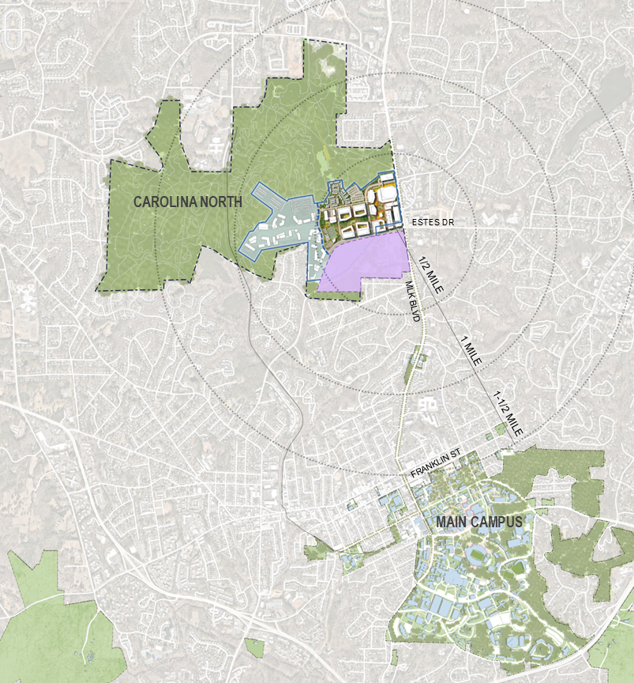
Overview
The University of North Carolina at Chapel Hill (the University) is soliciting submittals from qualified firms interested in providing development advisory for the initial phase of development at Carolina North. The selected advisor will assist the University from strategic planning through facilitating the selection of a master developer. Firms may express interest and request consideration by submitting responsive materials to the University as set forth in this Request for Proposals (RFP).

I. Project Description
Carolina North is a term used to describe 947 acres of contiguous land located roughly two miles north of the University’s main campus. The land is fully owned by the University and consists mostly of forested area that is traversed by recreational trails. Approximately 228 of developable land centered around the former Horace Williams Airport were identified in a 2005 study. It is this portion of the site that the University seeks to develop, likely in multiple phases.

The University’s development vision for Carolina North is to create an additional center of gravity for UNC, the Triangle, and the State that embodies the aspirational spirit of the institution; to develop an innovative campus that supports the academic, research, and service mission of UNC while also strengthening the Athletics program and acting as a destination for the broader community; and to ensure a vibrant, walkable, connected place that reflects the character and quality of Main Campus, and celebrates a unique identity for Carolina North.

The University recently engaged with the SmithGroup to develop a revised concept master plan for Carolina North. The concept plan is shaped by several key program drivers:
- Enrollment and Academic Program Growth: Projected enrollment growth of 5,000 undergraduate students over the next ten years will drive the need for additional student housing, both for undergraduate and graduate students. Expanding and new academic programs will necessitate the need for new facilities.
- Athletics: Pending a Basketball Arena and Training Facility Study report’s final findings, a potential new athletics facility would drive growth, energy, and opportunities for development that would redefine the University’s place with the region.
- Commercial Mixed-Use Development: The potential for a new basketball arena, coupled with University and regional growth, will drive the need for commercially viable mixed-use development, including hospitality, retail, entertainment and office/innovation space.
- Affordable and Market Housing: Development of affordable and market rate housing for faculty, staff and the broader community will be an important component of the success of Carolina North.
The initial phase of the concept plan comprises approximately 90 acres. Outside of academic buildings and the potential arena/training facility, which the University expects to self-perform, the University seeks a master developer for all other aspects of development activity.

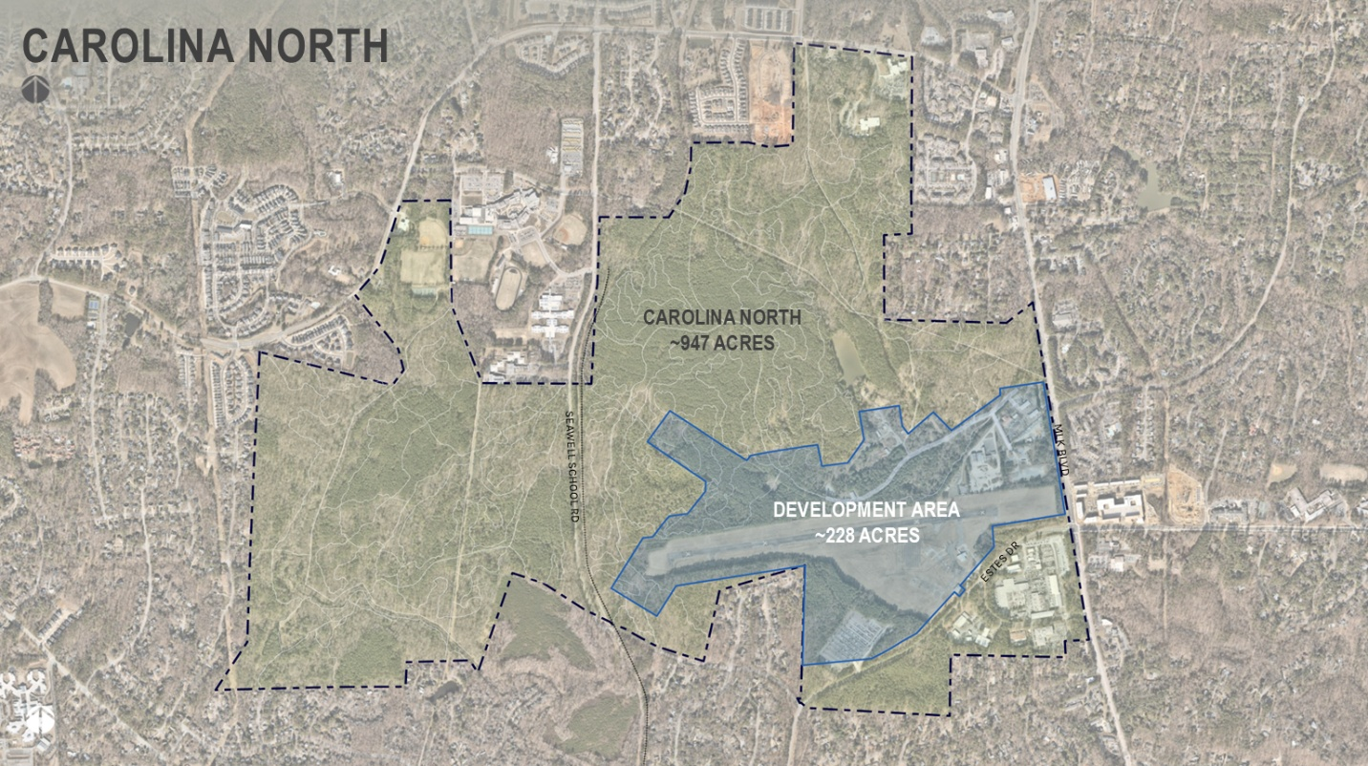

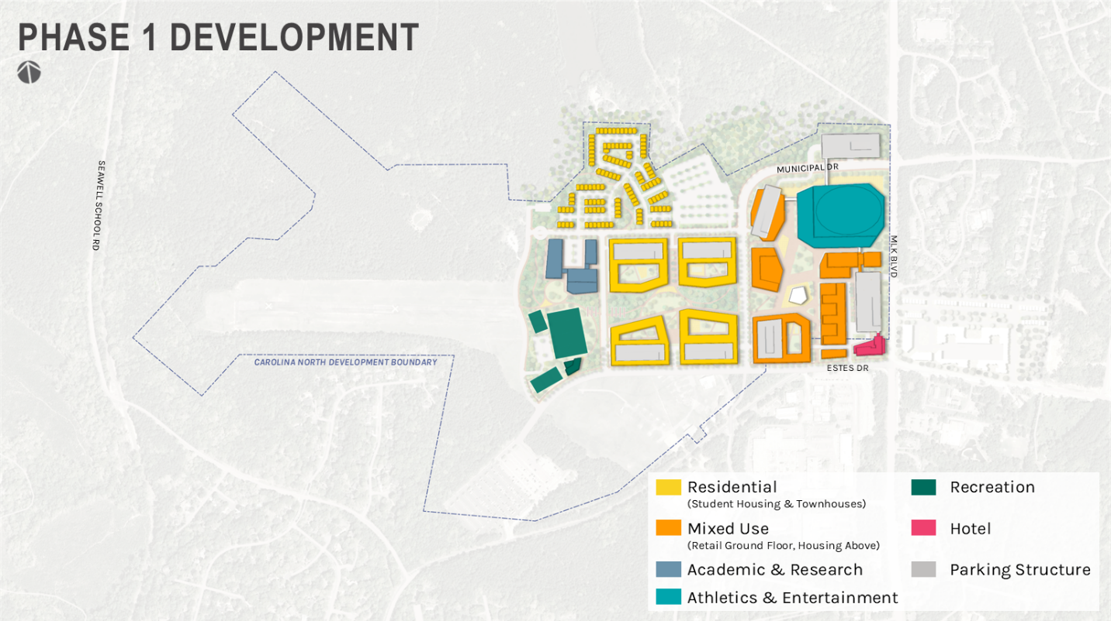

II. Project Scope
The University Is seeking an advisor to provide guidance and support to the University as it develops and executes the development program for Carolina North. The required the scope of work includes the following:
- Strategic Planning, Development Strategy and Deal Structuring
  - Conduct a market assessment to inform development potential of the initial phase of the concept plan (~90-acre site)
  - Identify potential ownership structures, project pro forma models, and land residual values and related scenario planning to determine best financing structure for other use types.
- Master Developer Outreach and Selection (Required)
  - Prepare Request for Qualifications (RFQ) and/or Request for Proposals (RFP)
  - Identify outreach to qualified development partners and manage outreach to these partners
  - Evaluate and summarize responses and develop a framework for ranking and shortlisting firms
  - Support interviews, final evaluations, and negotiation processes

The University may consider the following optional services as part of its scope of work:
- Transaction Support
  - Assist in negotiating term sheets, letters of intent, and/or final agreements as required by the University

Please ensure that your pricing includes both required and optional scope of work.

III. Advisory team
The University expects to select a development advisor with this RFP process. Respondents are not required to submit specialized sub-consultants (unless they choose to do so). The University’s Financial Advisor (FAs) and other professional services providers will collaborate throughout the process. Additional team members will be added as needed (i.e., outside counsel). The specific scope of work for this effort will be developed collaboratively by the University and the preferred firm following selection.

IV. Submittal Requirements
The University seeks responses from firms who have recent advisory experience with similar projects of similar scale and magnitude. Please respond to each of the following items outlined below. Failure of the respondent to provide any of the information requested in this RFP could result in disqualification. Submittals must address the following relevant items:
- Cover Letter: A cover letter describing the Respondent’s interest and experience and key reasons why the Respondent is best qualified to serve as the University’s development advisor. The letter should be executed by a legal signatory and include the complete legal name, address of the office leading the submission, contact information for the primary point of contact, and corporate website.

- Firm History and Team Members: Provide a brief firm history and an overview of the proposed project team for this effort, including:
  - An overview of the firm, including history, locations, services offered, and institutions served
  - Resumes of key personnel assigned to the project, highlighting their relevant development advisory experience with large-scale mixed-use development projects involving uses contemplated by the concept plan
  - Organizational structure of the proposed project team outlining the roles/responsibilities, time commitment, and location of each team member
  - A commitment to the availability of proposed key personnel throughout the duration of the project

- Relevant Experience: Present no more than five (5) comparable development advisory projects that clearly demonstrate your firm’s ability to provide comprehensive development advisory services to meet the University’s goals for this effort. Each project example should include the following key information:
  - Project location, name, and institution
  - Project size (mixed-use program elements included, gross square feet, construction cost, and total development cost if available)
  - Scope of services provided and key outcomes
  - Time period advisory services were provided
  - Transaction/ownership and financing structure
  - Reference for each project

- Process and Approach: Describe your firm’s process and approach to providing development advisory services to the University for this effort. Explain how your team will work closely with the University to successfully evaluate project delivery and feasibility options, structure a competitive solicitation, select a development partner, and negotiate project agreements with the preferred developer (optional). Please include the following items and any others that are relevant:
  - Description of key activities
  - Approach to collaboration with the University and relevant stakeholders
  - Schedule / workplan covering the entire advisory period for the initial project(s)
  - Challenges you anticipate facing with the assignment and how you will address them
  - Unique considerations or expertise that your team will bring to the advisory assignment

5. Fee Schedule: a.

V. Submittal Process

In addition to specifications listed in the RFP document as to pre-proposal Zoom call, time of delivery, etc.:
Please limit the length to no more than a total of twenty-five (25) pages (the front and rear of a page are considered two pages; covers and tabs are not included in the page limit). All responses should be submitted in Adobe PDF format and in accordance with the requirements outlined herein.

Note: (1) one electronic PDF file of the submittal is required via email. The file should be no more than 25.0MB in size.

All submissions in response to this RFP will be reviewed for responsiveness prior to referral to the Selection Committee. Those individuals will review, evaluate, score, and rank all responsive submissions. To fairly evaluate the submittals and to better utilize the Selection Committee’s review time, we request that only pertinent information relating to the criteria listed herein is provided. The University reserves the right to conduct interviews if necessary. Respondents will be notified accordingly.

All questions and project submittals shall be directed to the Buyer at bohlin@ad.unc.edu.

