

Wayne County

North Carolina

Date of Issue: August 4 , 2026
Bids Due: August 27, 2026
Time: 2:00 pm

Request for Bids
For Housing Demolition Services
Related to the 2021
Community Development Block Grant-
Neighborhood Revitalization (CDBG-NR) Project

If you have received this RFB from a source other than the Wayne County Purchasing Department, it is the responsibility of the proposer to ensure that all addenda have been received. Bidders can notify Mandy Trujillo by email at amanda.trujillo@waynegov.com to ensure that your company is added to the distribution list.

However, it is still the responsibility of the proposer to ensure that all addenda are received prior to submitting a qualification packet.

I. INVITATION TO BID

Sealed bids for the demolition/clearance and asbestos removal of one (1) house will be received at the Wayne County Courthouse, Finance Department, 224-226 East Walnut Street, 4th Floor, Goldsboro, NC 27530 on Thursday, August 27, 2026 at 2:00 pm and then will be publicly opened and read aloud. Proposals may be submitted to Mandy Trujillo, Procurement Specialist, Finance Dept., Wayne County Court House, 224-226 East Walnut Street, 4th Floor, Goldsboro, NC 27530 or delivered to same prior to the bid opening. Mark the outside of the sealed envelope “Bid Proposal for CDBG-NR Demolition of Housing Unit.” For more information, contact Mandy Trujillo at Amanda.Trujillo@waynegov.com or 919-705-1714.

Wayne County has received $750,000 in federal 2021 CDBG-NR grant funds representing 100% of total project costs to undertake housing rehabilitation, clearance, and reconstruction (replacement housing on site) activities. All federal CDBG requirements will apply to the Contract. The successful bidder on this work will be required to comply with federal regulations: Section 109 and E.O. 11246 which prohibits discrimination in employment regarding race, creed, color, sex, or national origin; Title VI of the Civil Rights Act of 1964; Anti-Kickback Act; E-Verify Regulations; and Contract Work Hours and Safety Standards Act. Wayne County is committed to and supportive of efforts to effectively maintain and/or increase the use of Small and Minority/Women Owned Business and Historically Underutilized Businesses (HUB) contract participation for construction projects; services (including professional and consulting services); and commodities purchases. Wayne County is also committed to increase contractor participation in employment, training and contracting opportunities to low and very low-income persons in the county in accordance with Section 3 of the Housing and Urban Development Act of 1968, as amended.

Wayne County is an Equal Opportunity Employer and Service Provider and encourages small, minority owned, women owned, veteran owned, Historically Underutilized Businesses (HUB), and/or Section 3 businesses to submit bids. Wayne County supports and encourages community support of the Fair Housing Act in local housing activities which prohibits discrimination in housing based on race, color, national origin, religion, sex, family status, and disability.

Bidders may not be debarred from receiving state or federal contracts. Wayne County reserves the right to reject any and/or all bids, and to waive defects, technicalities, and/or irregularities in any bid submittal.

II. STANDARD TERMS AND CONDITIONS

- Payment Terms. Payment terms are Net 30 days after receipt of applicable invoice.

- Compliance with All Laws. Contractor warrants that all performance hereunder shall be in accordance with all applicable federal, state and local laws, regulations and orders. If the source of funds for this contract is federal funds, the following federal provisions apply pursuant to 2 C.F.R. § 200.326 and 2 C.F.R. Part 200, Appendix II (as applicable): Equal Employment Opportunity (41 C.F.R. Part 60); Davis-Bacon Act (40 U.S.C. 3141-3148); Copeland “Anti-Kickback” Act (40 U.S.C. 3145); Contract Work Hours and Safety Standards Act (40 U.S.C. 3701-3708); Clean Air Act (42 U.S.C. 7401-7671q.); the Federal Water Pollution Control Act (33 U.S.C. 1251-1387); Debarment and Suspension (Executive Orders 12549 and 12689); Byrd Anti-Lobbying Amendment (31 U.S.C. 1352); Procurement of Recovered Materials (2 C.F.R. § 200.322); and Record Retention Requirements (2 CFR § 200.324).

- E-verification. Contractor and any of its subcontractors must comply with the requirements of the North Carolina General Statutes, if applicable, which requires certain employers to verify the work authorization of each newly hired employee through the federal E-Verify program operated by the United State Department of Homeland Security and other federal agencies.

- Iran Divestment Act Certification. Contractor hereby certifies that Contractor, and all subcontractors, are not on the Final Iran Divestment List (“List”) created by the North Carolina State Treasurer pursuant to NCGS 147, Article 6E. Contractor shall not utilize any subcontractor that is identified on the List.

- Indemnification. Contractor shall indemnify and hold harmless Wayne County, its officers, agents, employees and assigns from and against all claims, losses, costs, damages, expenses, attorneys’ fees and liability that any of them may sustain (a) arising out of Contractor’s failure to comply with any applicable law, ordinance, or regulation or (b) arising directly or indirectly out of Contractor’s performance or lack of performance of their terms and conditions of the Contract. In event Contractor, its employees, agents, subcontractors and or lower-tier subcontractors enter premises occupied by or under the control of Wayne County in the performance of the Contract Documents, Contractor agrees that it will indemnify and hold harmless Wayne County, its officers, agents, employees and assigns, from any loss, costs, damage, expense or liability by reason of property damage or personal injury of whatsoever nature or kind arising out of, as a result of, or caused by the negligence or willful misconduct of such entrant.

- Insurance. Contractor certifies that it currently has and agrees to purchase and maintain during its performance under this contract the following insurance from one or more insurance companies acceptable to Wayne County and authorized to do business in the State of North Carolina.
  - Worker’s Compensation: Coverage to apply for all employees for statutory limits in compliance with the applicable state and federal laws. The policy must include the employers’ liability with a limit $1,000,000 each accident. This insurance must include a waiver of subrogation in favor of the County.
  - Commercial General Liability: Shall have minimum limits of $1,000,000 per occurrence combined single limit for bodily injury liability and property damage liability.
  - Commercial Auto Liability: Shall have minimum limits of $1,000,000 each accident combined single limit for bodily injury liability and property damage liability. This shall include owned vehicles, hired and non-owned vehicles, and employee non-ownership.
  - Contractor shall furnish a copy of an original Certificate of Insurance, naming Wayne County as an additional insured. Should any of the policies be canceled before expiration date, the issuing company will provide by mail thirty (30) days written notice to the certificate holder. Contractor shall furnish insurance in satisfactory limits, and on forms and of companies which are acceptable to Wayne County and shall require and show evidence of insurance coverage on behalf of any subcontractors (if applicable), before entering any agreement to sublet any part of the work to be completed under this contract.

- Termination for Convenience. In addition to all of the other rights that Wayne County may have to cancel this Agreement, Wayne County shall have the further right, without assigning any reason therefore, to terminate any work under the Contract Documents, in whole or in part, at any time by providing written notice to Contractor. If the Contract is terminated by Wayne County in accordance with this Paragraph, Contractor will be paid for services actually provided up through the date of termination at the rates provided herein.

- Termination for Default. Wayne County may terminate this Contract, in whole or in part, for failure of Contractor to perform any of the provisions hereof. In addition to any other remedies available to Wayne County in law or equity in connection with an uncured breach of the Contract by Contractor, Wayne County may procure upon such terms as Wayne County shall deem appropriate, services substantially similar to those so terminated, in which case Contractor shall be liable to Wayne County for any excess costs for such similar supplies or services and any expenses incurred in connection therewith.

- Contract Funding. It is understood and agreed between Contractor and Wayne County that Wayne County’s obligation for payments is contingent upon the availability of appropriated CDBG grant funds from which payment for Contract purposes can be made. No legal liability on the part of Wayne County for any payment may arise until funds are made available to Wayne County’s Finance Officer and until Contractor receives notice of such availability. Should such funds not be appropriated or allocated, the Contract shall immediately be terminated. Wayne County shall not be liable to Contractor for damages of any kind (general, special, consequential or exemplary) as a result of such termination.

- Contract Modifications. The Contract may be amended only by written amendment duly executed by both Wayne County and Contractor. However, minor modifications may be made by Wayne County’s CDBG Project Manager to take advantage of unforeseen opportunities that: (a) do not change the intent of the Contract or the scope of Contractor’s performance; (b) do not increase Contractor’s total compensation or method of payment; and (c) either improve the overall quality of the product or service to Wayne County without increasing the cost, or reduce the total cost of the product or service without reducing the quantity or quality. All such minor modifications to the Contract must be recorded in writing and signed by both Wayne County and Contractor, and placed on file with the Contract. No price adjustments will be made unless the procedure has been included in the Contract and a maximum allowable amount stipulated.

- Independent Contractor. Contractor is an independent contractor and not an employee of Wayne County. The conduct and control of the work will lie solely with Contractor. The Contract shall not be construed as establishing a joint venture, partnership or any principal-agent relationship for any purpose between Contractor and Wayne County. Employees of Contractor shall remain subject to the exclusive control and supervision of Contractor, which is solely responsible for their compensation.

- Permits and Licenses. Contractor will, at his own expense, obtain all necessary permits, give all notices, pay all license fees and comply with all laws, rules, ordinances, and regulations relating to the preservation of the public health or applicable to the services or business carried on under this contract. The burden of determining applicability of licensing requirements, laws, ordinances, and regulations for the Contractor and his employees rests with the Contractor.

- Nondiscrimination. During the performance of the Contract, Contractor shall not discriminate against or deny the Contract’s benefits to any person on the basis of sexual orientation, national origin, race, ethnic background, color, religion, gender, age, or disability.

- Conflict of Interest. Contractor represents and warrants that no member of Wayne County or any of its employees or officers who may obtain a direct benefit, personal gain or advantage for themselves or a relative or associate as a result of the Contract, subcontract or other agreement related to the Contract is in a position to influence or has attempted to influence the making of the Contract, has been involved in making the Contract, or will be involved in administering the Contract. Contractor shall cause this paragraph to be included in all Contracts, subcontracts and other agreements related to the Contract.

- Gratuities to Wayne County. The right of Contractor to proceed may be terminated by written notice if Wayne County determines that Contractor, its agent or another representative offered or gave a gratuity to an official or employee of Wayne County in violation of the policies of Wayne County.

- Kickbacks to Contractor. Contractor shall not permit any kickbacks or gratuities to be provided, directly or indirectly, to itself, its employees, subcontractors or subcontractor employees for the purpose of improperly obtaining or rewarding favorable treatment in connection with the Contract or in connection with a subcontract relating to the Contract. When Contractor has grounds to believe that a violation of this clause may have occurred, Contractor shall promptly report to Wayne County in writing the possible violation.

- Monitoring and Evaluation. Contractor shall cooperate with Wayne County, or with any other person or agency as directed by Wayne County, in monitoring, inspecting, auditing or investigating activities related to the Contract. Contractor shall permit Wayne County to evaluate all activities conducted under the Contract. Wayne County has the right at its sole discretion to require that Contractor remove any employee of Contractor from Homeowner property and from performing services under the Contract following a provision of notice to Contractor of the reasons for Wayne County’s dissatisfaction with the services of Contractor’s employee.

- Financial Responsibility. Contractor is financially solvent and able to perform under the Contract. If requested by Wayne County, Contractor agrees to provide a copy of its latest audited annual financial statements or other financial statements as deemed acceptable by Wayne County’s Finance Officer. In the event of any proceedings, voluntary or involuntary, in bankruptcy or insolvency by or against Contractor, the inability of Contractor to meet its debts as they become due or in the event of the appointment, with or without Contractor’s consent, of an assignee for the benefit of creditors or of a receiver, then Wayne County shall be entitled, at its sole option, to cancel any unfilled part of the Contract without any liability whatsoever.

- Dispute Resolution and Contract Situs. This Agreement shall be governed and will be construed in accordance with the laws of the State of North Carolina. Each party agrees that exclusive venue for all actions, relating in any manner to this Agreement will be in the General Court of Justice in Wayne County, North Carolina.

- No Third Party Benefits. The Contract shall not be considered by Contractor to create any benefits on behalf of any third party. Contractor shall include in all contracts, subcontracts, or other agreements relating to the Contract an acknowledgment by the contracting parties that the Contract creates no third party benefits.

- Force Majeure. “Force Majeure” shall mean any delays caused by acts of God, riot, war, terrorism, inclement weather, labor strikes, material shortages and other causes beyond the reasonable control of the affected party. If either party is unable to perform its obligations or in the case of Wayne County, to accept the Services because of Force Majeure, the time for such performance by such party or in the case of Wayne County, acceptance of Services will be equitably adjusted by allowing additional time for performance or acceptance of services equal to any periods of Force Majeure.

- General Provisions. Wayne County’s remedies as set forth herein are not exclusive. Any delay or omission in exercising any right hereunder, or any waiver of any single breach or default hereunder, shall not be deemed to be a waiver of such right or of any other right, breach, or default. If Wayne County should prevail in any action instituted by Contractor hereunder, Wayne County shall be entitled to recover costs and reasonable attorney’s fees. Contractor may not assign, pledge, or in any manner encumber Contractor’s rights under this Order, or delegate the performance of any of its obligations hereunder, without Wayne County’s prior, express, written consent.

- Entire Contract. This Contract constitutes and expresses the entire agreement and understanding between the parties concerning the subject matter of this Contract. This document, including exhibits, if any, any purchase order used in connection with this Contract and any other document expressly incorporated in this Contract by reference supersede all prior and contemporaneous discussion, promises, representations, agreements, and understandings relative to the subject matter of this Contract.

IX. ADDITIONAL TERMS AND CONDITIONS

- NON-COLLUSION AFFIDAVIT
Each qualification package must be accompanied by a notarized affidavit on non-collusion, executed by the firm or in the case of a corporation, by a duly authorized representative of said corporation. The Non-Collusion Affidavit is provided herein.

- ADDENDA/CHANGES
Any additions, deletions, modifications or changes made to this Request for Bids shall be processed through the Wayne County Finance Department. Any deviation from this procedure may result in the disqualification of the firm’s submittal or the cancellation of any contract resulting from this Request for Bids.

X. CONTACT POLICY

After the date and time established for receipt of proposals by the County, any contact initiated by any firm with any County representatives, other than the Purchasing Manager listed herein, concerning this Request for Bids is prohibited. Any such unauthorized contact may cause the disqualification of the firm from this qualification process.

The County is an Equal Opportunity Employer and Service Provider and invites the submission of proposals from small and minority and women-owned firms, veteran-owned firms, historically underutilized businesses, and certified/registered Section 3 business concerns.

This information is available in Spanish or any other language upon request. Please contact Mandy Trujillo at 919-705-1714 or at County Courthouse, 224 E. Walnut St, Goldsboro, NC 27533, for accommodations for this request.

Esta información está disponible en español o en cualquier otro idioma bajo petición. Por favor, póngase en contacto con Mandy Trujillo al 919-705-1714 o en County Courthouse, 224 E. Walnut St, Goldsboro, NC 27533 de alojamiento para esta solicitud.



WAYNE COUNTY 2021 CDBG-NR HOUSING ASSISTANCE PROJECT

Scope of Work and Bid Proposal for

Demolition/Clearance with Asbestos Removal of One Housing Unit

WORK DESCRIPTION:

Homeowner Address
Herman Jones 1715 Old Mount Olive Hwy.
(919-750-1121) Dudley, NC 28333

Completely demolish the house structure from the property, including front concrete porch, brick steps and treated deck at right side and rear of house. Remove all debris/garbage around the house. Completely remove five bushes in front of house; remove one bush at left side of house and one at right side of house. Completely remove existing concrete driveway from highway to house; approximately 66’ feet x 12’ feet x 3”to 4” inches thick Remove small concrete sidewalk next to front concrete porch approximately 3’ feet x 16’ feet x 3” to 4” inches thick. Grade site, clean and level. Haul in sufficient fill dirt to cover holes and disturbed areas and to provide positive drainage. Cost of dirt to be included in the lump-sum proposal. Re-seed and hay-disturbed areas. Proposal to be turnkey and include all costs of disposal, including tipping fees to County landfill, labor, materials, permits, demolition permits, insurance, etc. The contractor is to provide copies of landfill tickets and proof of payment to the landfill. Contractor is to provide copies of invoices and proof of payment for any subcontractors that perform any work at job site. Contractor shall obtain and provide copy to the County of Wayne, Demolition Notification Permit from the NC Health Hazards Control Unit (HHCU). Chain link fences to remain. Storage, outbuildings to remain. See attached survey with clarifying instructions.

Cost of Demolition $

ASBESTOS REMOVAL

Completely remove the asbestos containing materials from the dwelling as identified in the attached asbestos report. Asbestos containing materials shall be removed by Contractor (if licensed as an asbestos removal contractor) or by a licensed and accredited asbestos sub-contractor prior to demolition of the house. Asbestos supervisors’ licenses and asbestos workers licenses shall be provided to the County prior to beginning asbestos removal. After asbestos has been removed, Contractor shall notify the County asbestos inspector to provide a Clearance Letter verifying the asbestos has been removed. The County will pay for the first post-removal inspection. The Contractor shall pay for any re-inspections that are required if the first inspection fails due to inadequate removal of the asbestos containing materials. Prior to contract payment, Contractor shall pay the asbestos inspection firm for any re-inspections and shall provide a paid receipt for each reinspection required to obtain the Clearance Letter.

Asbestos removal sub-contractor shall provide evidence of General Liability and Workmen’s Compensation Insurance at the same minimum levels of the Contractor. Contractor shall provide evidence of payment of asbestos removal sub-contractor prior to payment of property.

The processes for removal, hauling and disposal of asbestos containing material shall be in accordance with NC Health Hazards Control Unit (HHCU) requirements, NC Division of Solid Waste Management requirements and applicable federal requirements.

A NC Asbestos Waste Shipment Record shall be provided for all asbestos material that is 1% or greater. If required by NC Health Hazards Control Unit (HHCU), Contractor shall provide a copy of the Asbestos Removal Permit or the Demolition Notification Permit with Asbestos Removal from HHCU PRIOR TO BEGINNING ANY ASBESTOS REMOVAL WORK.

Cost of Asbestos Removal $_________________

TOTAL AMOUNT OF LUMP-SUM PROPOSAL $_________________

Respectfully submitted:
Signature Date

Print Name Title

Name of Company Telephone Number

Company Address Fed ID or SS Number

City, State, Zip Code NC Contractor’s License Number

SURVEY - 1715 Old Mount Olive Hwy, Dudley, NC 28333
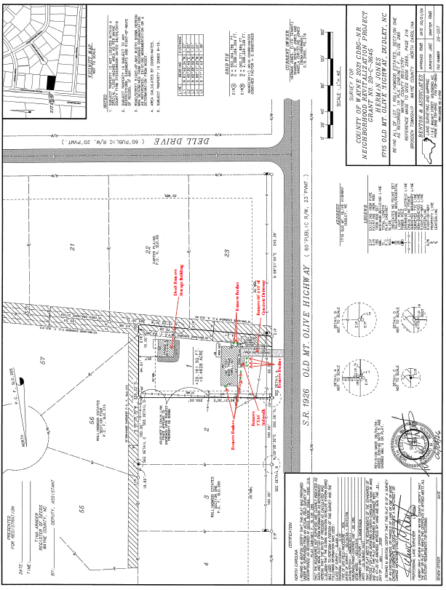

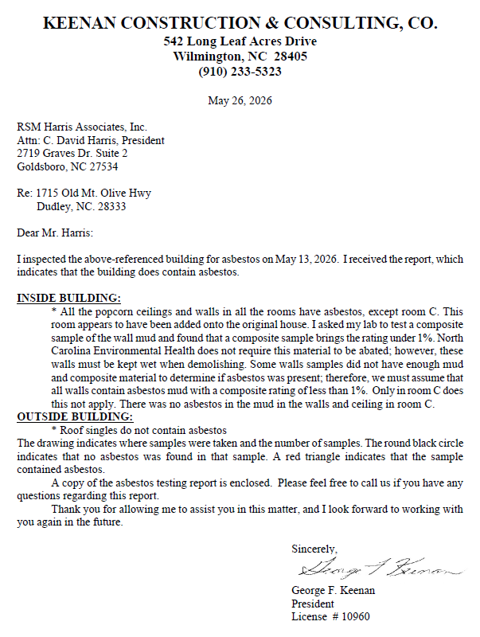

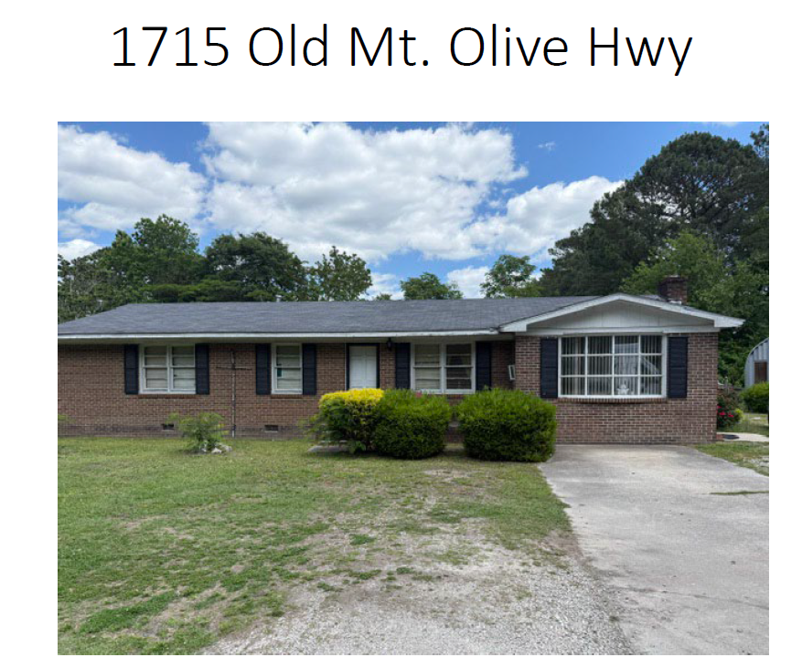

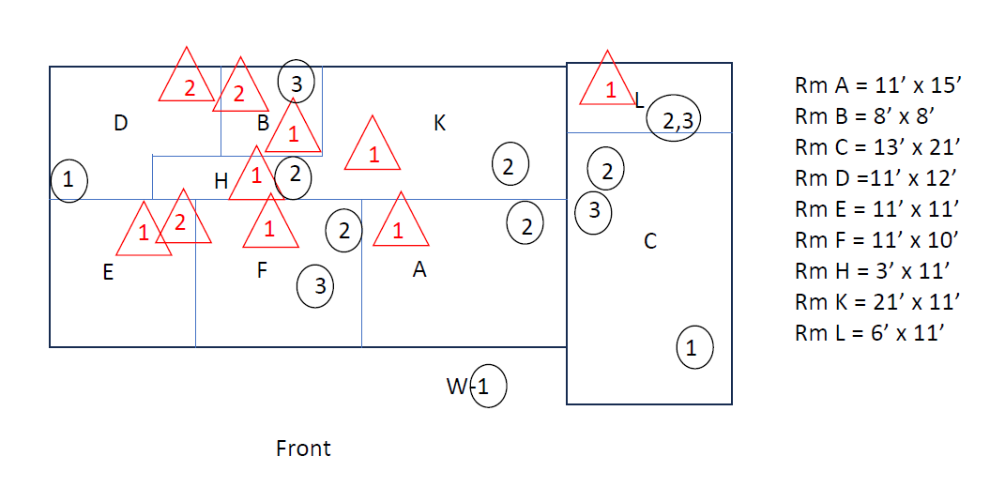

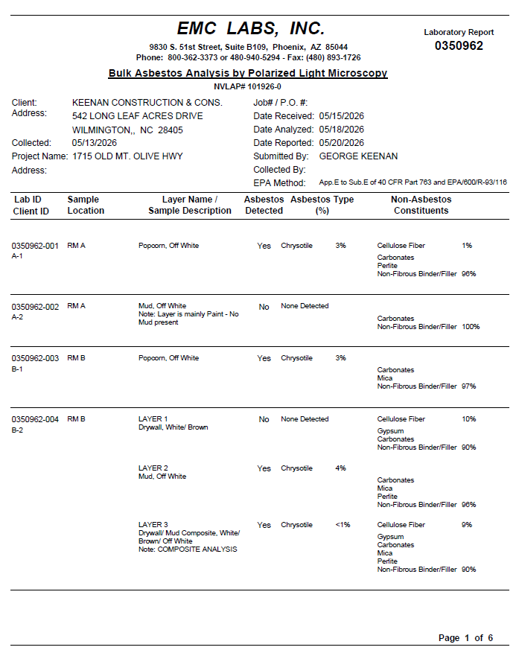

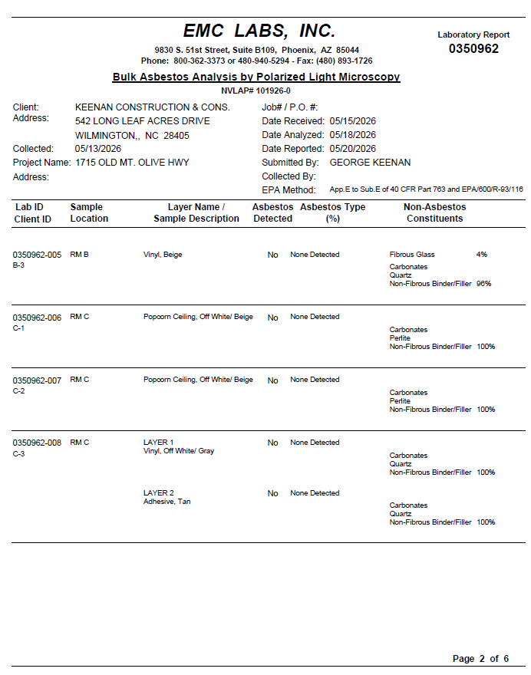

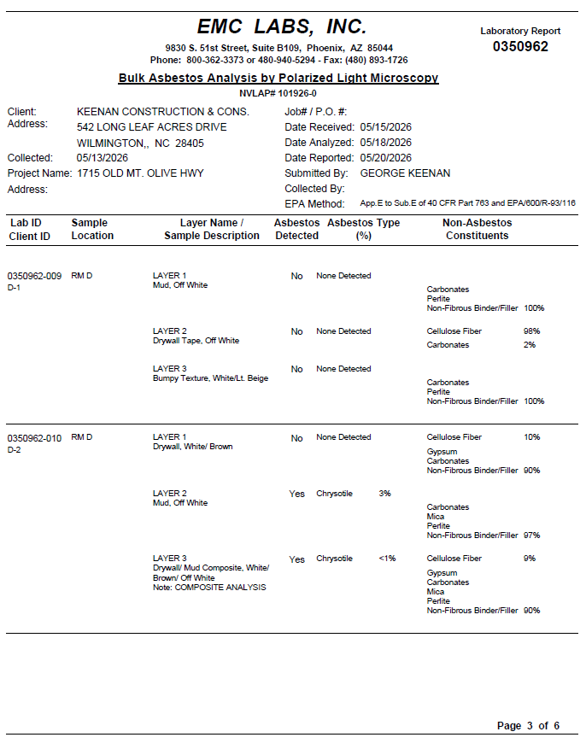

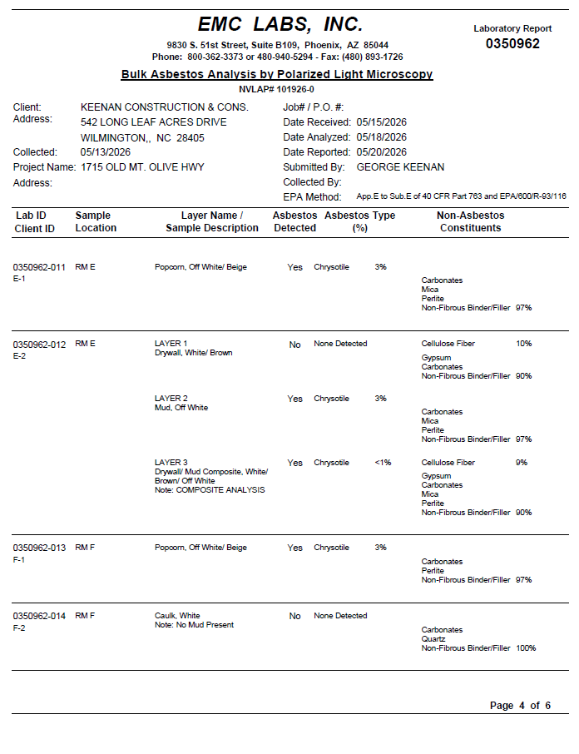

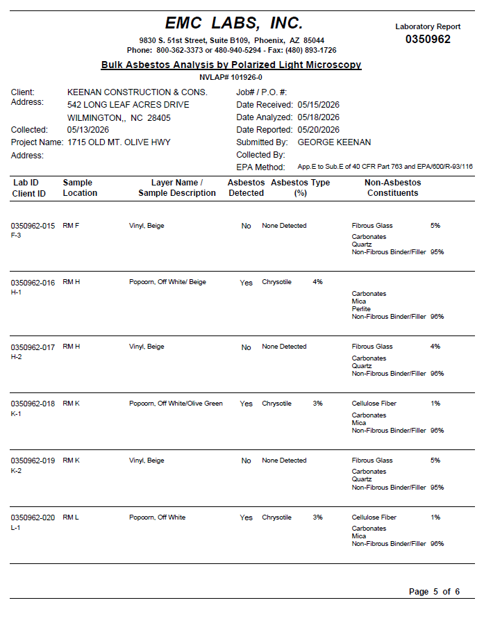
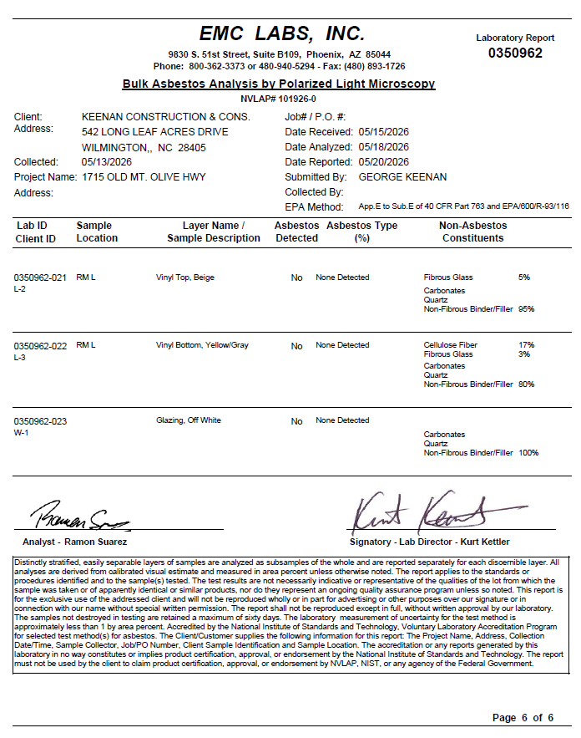

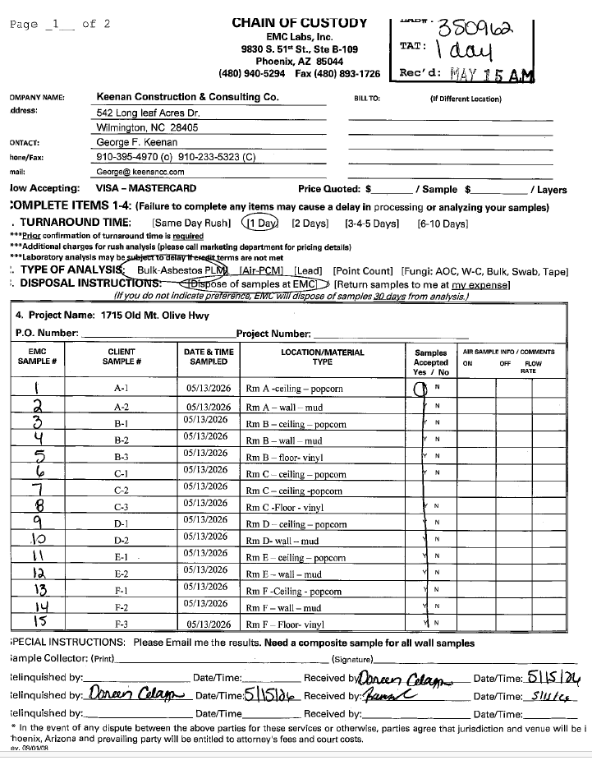
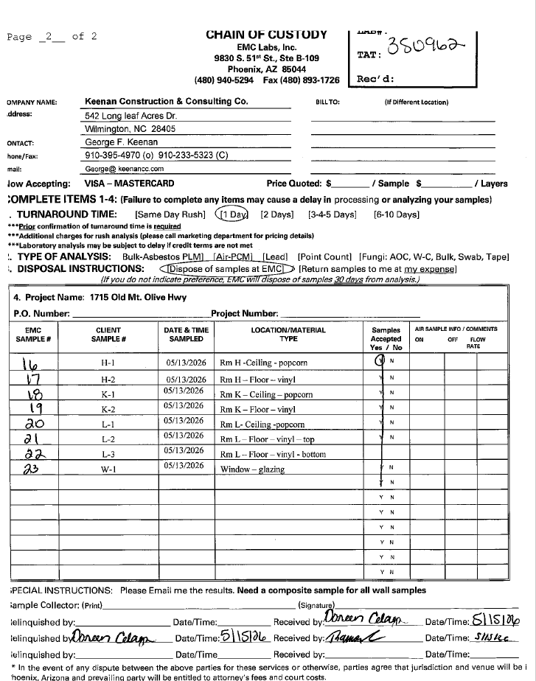

STATE OF NORTH CAROLINA
COUNTY OF _______________ AFFIDAVIT

***************************

I, _____________________________ (the individual attesting below), being duly authorized by and on behalf of
_________________________ (the entity bidding on project hereinafter “Employer”) after first being duly sworn hereby swears or affirms as follows:

1.Employer understands that E-Verify is the federal E-Verify program operated by the United States Department of Homeland Security and other federal agencies, or any successor or equivalent program used to verify the work authorization of newly hired employees pursuant to federal law in accordance with NCGS §64-25(5).

2. Employer understands that Employers Must Use E-Verify. Each employer, after hiring an employee to work in the United States, shall verify the work authorization of the employee through E-Verify in accordance with NCGS §64-26(a).

3. Employer is a person, business entity, or other organization that transacts business in this State and that employs 25 or more employees in this State. (Mark Yes or No)
a. Yes_____, or b. No_____

4. Employer’s subcontractors comply with E-Verify, and if Employer is the winning bidder on this project, Employer will ensure compliance with E-Verify by any subcontractors subsequently hired by Employer

This the ______ day of _____________________, 20____.

_______________________________
Signature of Affiant
Print or type Name: _______________
State of North Carolina
County of __________________

SWORN to and subscribed before me, ________________________. this the ______ day of
(Notary Public)
_______________, 20____, by ____________________.
(Affiant)
______________________________________
Notary Public
My commission expires:______________________

RESPONDER’S CERTIFICATION FORM
I have carefully examined the Request for Bids and any other documents accompanying or made a part of this Request for Bids.
I hereby propose to furnish the services for Wayne County in accordance with the instructions, terms, conditions, and requirements incorporated in this Request for Bids. I certify that all information contained in this response is truthful to the best of my knowledge and belief. I further certify that I am duly authorized to submit this response on behalf of the firm as its act and deed and that the firm is ready, willing and able to perform if awarded the contract.

NAME OF FIRM: _____________________________________________

BY: (printed name)_____________________________________________

SIGNATURE: _________________________________________________

MAILING ADDRESS: ____________________________________________

CITY/STATE/ZIP CODE: _________________________________________

TELEPHONE NUMBER: __________________________________________

FAX NUMBER: _________________________________________________

Acknowledgement of Addenda
Responder hereby acknowledges receipt of all Addenda through and including:

Addendum No. Date Acknowledgement
__________ __________ _______________
__________ __________ _______________
__________ __________ _______________
__________ __________ _______________

NON-COLLUSION AFFIDAVIT
State of North Carolina
County of

____________________________, being first duly sworn, deposes and says that:

l. He/She is the ___________________ (title) of ___________________________(firm’s name), the responder that has submitted the attached response;

2. He/She is fully informed respecting the preparation and contents of the attached response and of all pertinent circumstances respecting such response;

3. Such response is genuine and is not a collusive or sham response;

4. Neither the said responder nor any of its officers, partners, owners, agents, representatives, employees or parties in interest, including this affiant, has in any way colluded, conspired, connived or agreed, directly or indirectly, with any other responder firm or Person to submit a collusive or sham response in connection with the contract for which the attached response has been submitted or to refrain from responding in connection with such contract, or has in any manner, directly or indirectly sought by agreement or collusion of communication or conference with any other responder, firm or person to fix the price or prices in the attached response, if applicable, or of any other responders, or to fix any overhead, profit or cost element of the response price of the response, if applicable, of any other responder or to secure through collusion, conspiracy, connivance or unlawful agreement any advantage against the County of Wayne or any person interested in the proposed contract; and

________________________________
Signature

_________________________________
Title
NOTARIZE

Subscribed and sworn to before me,
This ______ day of ____________________, 20___
Notary Public ______________________________
My Commission Expires: ______________________

CERTIFICATIONS REGARDING DEBARMENT, SUSPENSION AND OTHER

RESPONSIBILITY MATTERS

CONTRACTOR should refer to the regulations cited below. CONTRACTOR should also review the instructions for certification included in the regulations before completing this form. Signature on this form provides for compliance with certification requirements implementing Federal Executive Order 12549 and guidance issued in the Federal Register, Volume 70, No. 168, pages 51863 through 51880 for “Government wide Debarment and Suspension (Non-procurement).” The certification shall be treated as a material representation of fact upon which reliance will be placed when the NC Department of Commerce or its grantee (COUNTY) determines to award the covered contract, transaction, grant or cooperative agreement.
DEBARMENT, SUSPENSION AND OTHER RESPONSIBILITY MATTERS
As required by Executive Order 12549, Debarment and Suspension, for prospective participants CONTRACTOR in primary covered transactions.
- The prospective primary participant (CONTRACTOR) certifies to the best of its knowledge and belief, that it and its principals:
- Are not presently debarred, suspended, proposed for debarment, declared ineligible, or voluntarily excluded from covered transactions by a Federal department or agency;
- Have not within a three-year period preceding this proposal been convicted of or had a civil judgment rendered against them for commission of fraud or a criminal offense in connection with obtaining, attempting to obtain, or performing a public (Federal, State or local) transaction or contract under a public transaction; violation of Federal or State antitrust statutes or commission of embezzlement, theft, forgery, bribery, falsification or destruction or records, making false statements, or receiving stolen property:
- Are not presently indicted for or otherwise criminally or civilly charged by a governmental entity (Federal, State or local) with commission of any of the offenses enumerated in paragraph (1)(b) of this certification; and
- Have not within a three-year period preceding this proposal had one or more public transactions (Federal, State, or local) terminated for cause or default.
- Where the prospective primary participant (CONTRACTOR) is unable to certify to any of the statements in this certification, such prospective participant (CONTRACTOR) shall attach an explanation to this proposal.

As the duly authorized representative of the CONTRACTOR, I hereby certify that I will comply with the above applicable certification(s).
NAME OF CONTRACTOR | GRANT NUMBER AND PROJECT NAME  Wayne County 2021 CDBG-NR Project  Grant Number 20-C-3645

PRINTED NAME AND TITLE OF AUTHORIZIED REPRESENTATIVE

SIGNATURE | DATE

Provisions in CDBG Contracts Regarding Federal Requirements, As Applicable

Appendix II – Title 2 CFR Part 200—Contract Provisions for Non-Federal Entity Contracts Under Federal Awards
In addition to other provisions required by the Federal agency or non-Federal entity, all contracts made by the non-Federal entity under the Federal award must contain provisions covering the following, as applicable.
(A) Contracts for more than the simplified acquisition threshold currently set at $150,000, which is the inflation adjusted amount determined by the Civilian Agency Acquisition Council and the Defense Acquisition Regulations Council (Councils) as authorized by 41 U.S.C. 1908, must address administrative, contractual, or legal remedies in instances where contractors violate or breach contract terms, and provide for such sanctions and penalties as appropriate.
(B) All contracts in excess of $10,000 must address termination for cause and for convenience by the non-Federal entity including the manner by which it will be effected and the basis for settlement.
(C) Equal Employment Opportunity. Except as otherwise provided under 41 CFR Part 60, all contracts that meet the definition of “federally assisted construction contract” in 41 CFR Part 60-1.3 must include the equal opportunity clause provided under 41 CFR 60-1.4(b), in accordance with Executive Order 11246, “Equal Employment Opportunity” (30 FR 12319, 12935, 3 CFR Part, 1964-1965 Comp., p. 339), as amended by Executive Order 11375, “Amending Executive Order 11246 Relating to Equal Employment Opportunity,” and implementing regulations at 41 CFR part 60, “Office of Federal Contract Compliance Programs, Equal Employment Opportunity, Department of Labor.”
(D) Davis-Bacon Act, as amended (40 U.S.C. 3141-3148). When required by Federal program legislation, all prime construction contracts in excess of $2,000 awarded by non-Federal entities must include a provision for compliance with the Davis-Bacon Act (40 U.S.C. 3141-3144, and 3146-3148) as supplemented by Department of Labor regulations (29 CFR Part 5, “Labor Standards Provisions Applicable to Contracts Covering Federally Financed and Assisted Construction”). In accordance with the statute, contractors must be required to pay wages to laborers and mechanics at a rate not less than the prevailing wages specified in a wage determination made by the Secretary of Labor. In addition, contractors must be required to pay wages not less than once a week. The non-Federal entity must place a copy of the current prevailing wage determination issued by the Department of Labor in each solicitation. The decision to award a contract or subcontract must be conditioned upon the acceptance of the wage determination. The non-Federal entity must report all suspected or reported violations to the Federal awarding agency. The contracts must also include a provision for compliance with the Copeland “Anti-Kickback” Act (40 U.S.C. 3145), as supplemented by Department of Labor regulations (29 CFR Part 3, “Contractors and Subcontractors on Public Building or Public Work Financed in Whole or in Part by Loans or Grants from the United States”). The Act provides that each contractor or subrecipient must be prohibited from inducing, by any means, any person employed in the construction, completion, or repair of public work, to give up any part of the compensation to which he or she is otherwise entitled. The non-Federal entity must report all suspected or reported violations to the Federal awarding agency.
(E) Contract Work Hours and Safety Standards Act (40 U.S.C. 3701-3708). Where applicable, all contracts awarded by the non-Federal entity in excess of $100,000 that involve the employment of mechanics or laborers must include a provision for compliance with 40 U.S.C. 3702 and 3704, as supplemented by Department of Labor regulations (29 CFR Part 5). Under 40 U.S.C. 3702 of the Act, each contractor must be required to compute the wages of every mechanic and laborer on the basis of a standard work week of 40 hours. Work in excess of the standard work week is permissible provided that the worker is compensated at a rate of not less than one and a half times the basic rate of pay for all hours worked in excess of 40 hours in the work week. The requirements of 40 U.S.C. 3704 are applicable to construction work and provide that no laborer or mechanic must be required to work in surroundings or under working conditions which are unsanitary, hazardous or dangerous. These requirements do not apply to the purchases of supplies or materials or articles ordinarily available on the open market, or contracts for transportation or transmission of intelligence.
(F) Rights to Inventions Made Under a Contract or Agreement. If the Federal award meets the definition of “funding agreement” under 37 CFR §401.2 (a) and the recipient or subrecipient wishes to enter into a contract with a small business firm or nonprofit organization regarding the substitution of parties, assignment or performance of experimental, developmental, or research work under that “funding agreement,” the recipient or subrecipient must comply with the requirements of 37 CFR Part 401, “Rights to Inventions Made by Nonprofit Organizations and Small Business Firms Under Government Grants, Contracts and Cooperative Agreements,” and any implementing regulations issued by the awarding agency.
(G) Clean Air Act (42 U.S.C. 7401-7671q.) and the Federal Water Pollution Control Act (33 U.S.C. 1251-1387), as amended—Contracts and subgrants of amounts in excess of $150,000 must contain a provision that requires the non-Federal award to agree to comply with all applicable standards, orders or regulations issued pursuant to the Clean Air Act (42 U.S.C. 7401-7671q) and the Federal Water Pollution Control Act as amended (33 U.S.C. 1251-1387). Violations must be reported to the Federal awarding agency and the Regional Office of the Environmental Protection Agency (EPA).
(H) Debarment and Suspension (Executive Orders 12549 and 12689)—A contract award (see 2 CFR 180.220) must not be made to parties listed on the governmentwide exclusions in the System for Award Management (SAM), in accordance with the OMB guidelines at 2 CFR 180 that implement Executive Orders 12549 (3 CFR part 1986 Comp., p. 189) and 12689 (3 CFR part 1989 Comp., p. 235), “Debarment and Suspension.” SAM Exclusions contains the names of parties debarred, suspended, or otherwise excluded by agencies, as well as parties declared ineligible under statutory or regulatory authority other than Executive Order 12549.
(I) Byrd Anti-Lobbying Amendment (31 U.S.C. 1352)—Contractors that apply or bid for an award exceeding $100,000 must file the required certification. Each tier certifies to the tier above that it will not and has not used Federal appropriated funds to pay any person or organization for influencing or attempting to influence an officer or employee of any agency, a member of Congress, officer or employee of Congress, or an employee of a member of Congress in connection with obtaining any Federal contract, grant or any other award covered by 31 U.S.C. 1352. Each tier must also disclose any lobbying with non-Federal funds that takes place in connection with obtaining any Federal award. Such disclosures are forwarded from tier to tier up to the non-Federal award.
(J) Sec. §200.322 Procurement of recovered materials.

SECTION 3 OF THE HOUSING AND URBAN DEVELOPMENT ACT OF 1968

Section 3 of the Housing and Urban Development Act of 1968 provides preference to low and very low-income residents of the community (regardless of race or gender), and the businesses that substantially employ these persons, for new employment, training, and contracting opportunities. Contractors doing work with Wayne County are to list any new hires with the local NCWorks Career Center and to report any new hires to the County. Firms are encouraged to provide preference to low-income community residents and residents in public housing units. Attached is information about Section 3. The following Section 3 clause will be included in all CDBG contracts where Section 3 applies.

A. The work to be performed under this Contract is subject to the requirements of Section 3 of the Housing and Urban Development Act of 1968, as amended (“Section 3”). The purpose of Section 3 is to ensure that employment and other economic opportunities generated by HUD assistance or HUD-assisted developments covered by Section 3, shall, to the greatest extent feasible, be directed to low- and very low-income persons including persons who are recipients of HUD assistance for housing, with preference for both targeted workers living in the service area or neighborhood of the Development and Youthbuild participants, as defined at 24 CFR Part 75 (“Section 3 Regulations”).
B. The Parties agree to comply with HUD's regulations in Section 3 Regulations, which implement Section 3. As evidenced by their execution of this Contract, the Parties certify that they are under no contractual or other impediment that would prevent them from complying with the Section 3 Regulations.
C. The Contractor agrees to send to each labor organization or representative or workers with which the contractor has a collective bargaining agreement or other understanding, if any, a notice advising the labor organization or workers’ representative of the contractor’s commitments under this Section 3 clause and will post copies of the notice in conspicuous places at the work site where both employees and applicants for training and employment positions can see the notice. The notice shall describe the Section 3 preference, shall set forth the following: (i) minimum number and job titles subject to hire, (ii) availability of apprenticeship and training positions, (iii) qualifications for each, (iv) name and location of the person(s) taking applications for each of the positions, and (v) the anticipated date the work shall begin.
D. The Contractor agrees to include this Section 3 clause in every subcontract subject to compliance with regulations in Section 3 Regulations and agrees to take appropriate action, as provided in an applicable provision of the subcontract or in this Section 3 clause, upon a finding that the subcontractor is in violation of the regulations in Section 3 Regulations. The Contractor will not subcontract with any subcontractor where the Contractor has notice or knowledge that the subcontractor has been found in violation of the regulations in Section 3 Regulations.
E. The Contractor will certify that any vacant employment positions, including training positions, that are filled (i) after a contractor is selected but before the contract is executed, and (ii) with persons other than those to whom the regulations of Section 3 Regulations require employment opportunities to be directed, were not filled to circumvent the Contractor’s obligations under Section 3 Regulations.
F. Noncompliance with HUD's regulations in Section 3 Regulations may result in sanctions, termination of this Contract for default, and debarment or suspension from future HUD assisted contracts.

