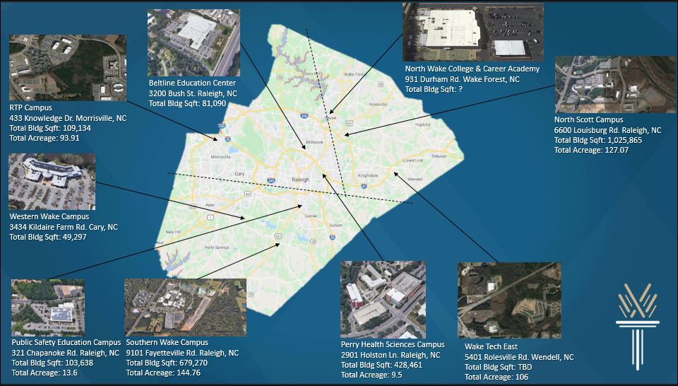
ATTACHMENT B- MAP OF CAMPUS LOCATIONS

