Solicitation Addendum

FAILURE TO RETURN THIS SOLICITATION ADDENDUM IN ACCORDANCE WITH INSTRUCTIONS MAY SUBJECT YOUR BID TO REJECTION ON THE AFFECTED ITEM(S)/SERVICES.

Solicitation Number: 58-IFB242003
Solicitation Description: Branded Signage
Bid Opening Date/Time: April 29, 2024 at 9:00 AM ET
Addendum Number: 04
Addendum Date: April 24, 2024

Fayetteville State University issues this addendum to solicitation 58-IFB242003 to remove Project #4 from the specifications of section 5.1.
The Solicitation is hereby modified as follows:
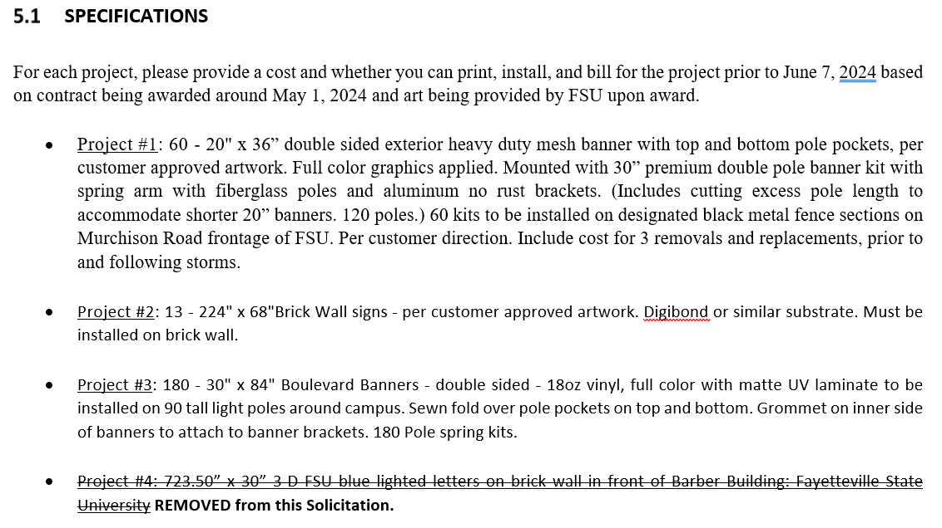

All other information contained in the RFP remains the same.

INSTRUCTIONS:

- Return one properly executed copy of this addendum prior to the Bid Opening Date/Time listed above.

- Check ONE of the following options:

☐ Bid has not been submitted. Any changes resulting from this addendum are included in our bid.

☐ Bid has already been submitted. No changes resulted from this addendum.

☐ Bid has already been submitted. Changes resulting from this addendum are as follows.

Execute Addendum:

Bidder: _______________________________________________________________

Authorized Signature: ________________________ Date: _____________________

Name and Title (Typed): _______________________________________________

