Board of Commissioners  Chairman  Edward riggs jr. - Township #3  Vice-Chairman  kari forrest – AT LARGE  doug brinson - At Large  Thomas mills - Township #1  candy bohmert – TOWNSHIP #2  Carl Ollison - Township #4  Kenny heath -Township #5 | 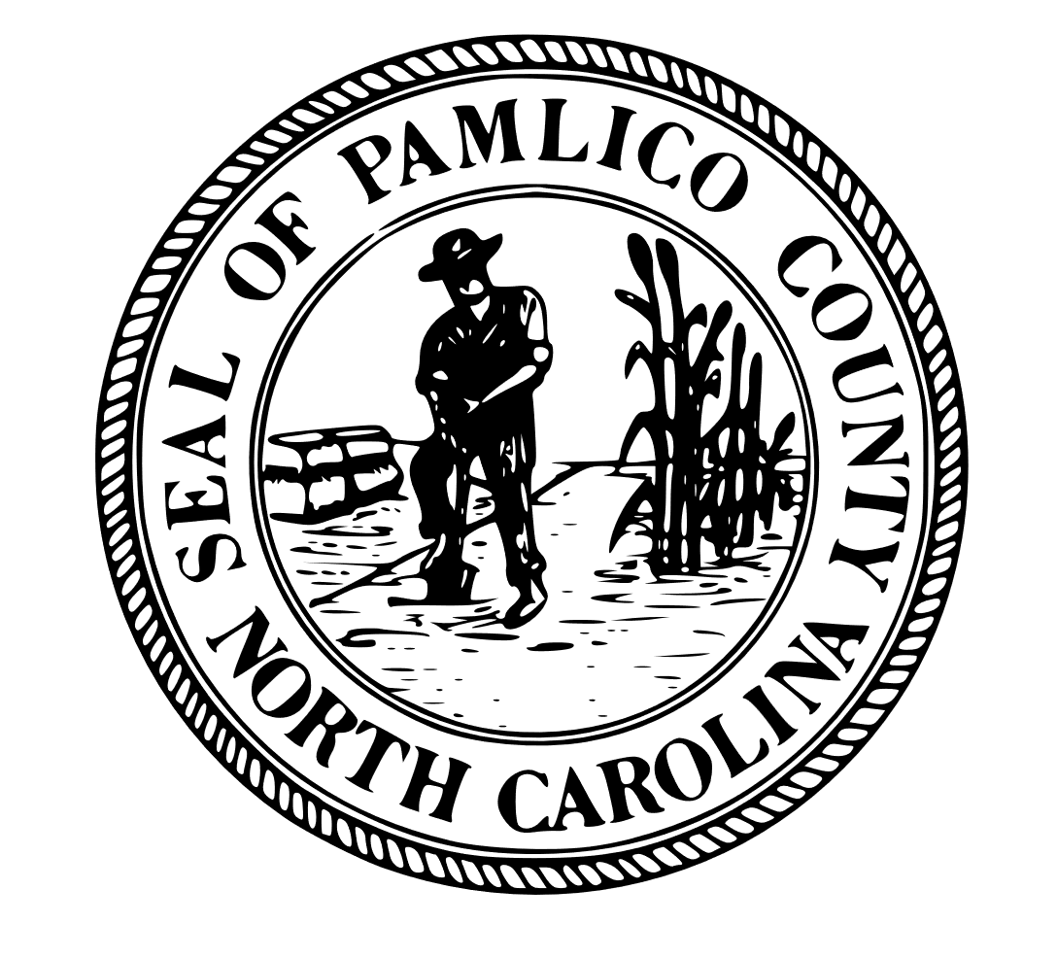  COUNTY OF PAMLICO  Post Office Box 776  Bayboro, North Carolina 28515  (252) 745-3133 / 745-5195  Fax (252) 745-5514 | County Manager  Mark brewington  Clerk to the Board  Tracy boyd  County Attorney  David B. Baxter, Jr.
_____________________________________________________________________________________
PAMLICO COUNTY, NORTH CAROLINA
REQUEST FOR QUALIFICATIONS
Professional Water Engineering Services
RFQ No.: RFQ-Water-2025
Issued By: Pamlico County, North Carolina
Issue Date: January 9, 2026
Reissue Date: February 3, 2026
Statements of Qualifications Due: February 13, 2026 at 5:00 PM
Submission Method: Email

Introduction and Purpose
Pamlico County, North Carolina (“County”), is soliciting Statements of Qualifications from qualified professional engineering firms to provide on-call water engineering services for the County’s public drinking water system. The purpose of this Request for Qualifications is to identify one or more firms with demonstrated experience in planning, design, permitting, funding assistance, and construction administration related to public water infrastructure.
This procurement is conducted in accordance with North Carolina General Statutes §143-64.31 governing qualifications-based selection of professional services. Selection will be based solely on professional qualifications and experience. Firms shall not submit pricing, fee schedules, hourly rates, or other cost information as part of this Request for Qualifications.
Pamlico County intends to establish a pool of qualified engineering firms to provide services on an as-needed basis. Selection under this RFQ does not guarantee the award of any specific project.

Background
Pamlico County owns and operates a public water system serving residents and businesses throughout the County. The system includes groundwater supply wells, water treatment processes, elevated and ground storage tanks, distribution mains, hydrants, valves, booster stations, and related appurtenances. The County anticipates the need for ongoing professional engineering support related to regulatory compliance, system reliability, rehabilitation of aging infrastructure, capital improvement planning, and future system improvements.

Scope of Services
Firms selected under this RFQ may be requested to provide professional services related to water system planning, evaluation, design, permitting, and construction. These services may include water system master planning; capital improvement planning and project prioritization; asset management and infrastructure condition assessments; hydraulic modeling; feasibility and alternatives analyses; well development, rehabilitation, and replacement; water treatment improvements; storage tank rehabilitation or replacement; distribution system extensions, looping, and replacement; pressure zone and booster station improvements; corrosion control and water quality optimization; and SCADA or system monitoring enhancements.
Selected firms may also be requested to assist with permitting and coordination with state and federal regulatory agencies, including preparation of plans and specifications consistent with applicable standards, support during inspections, and assistance with compliance documentation and reporting. Funding-related services may include preparation of preliminary engineering reports, cost estimates, schedules, environmental documentation, and assistance with state and federal funding programs such as the Drinking Water State Revolving Fund and USDA Rural Development.
Construction-phase services may include bidding assistance, construction administration, review of contractor pay applications and change orders, periodic site visits, and preparation of project close-out documentation.

Minimum Qualifications
Responding firms must be legally authorized to practice engineering in the State of North Carolina and must demonstrate experience providing professional services for public drinking water systems. Firms shall demonstrate familiarity with applicable state and federal drinking water regulations and experience working with local governments. Responding firms must maintain appropriate professional liability and general insurance coverage.

Statement of Qualifications Content
Statements of Qualifications shall be clear, concise, and limited to information relevant to this solicitation. Submittals shall include a cover letter identifying the firm, primary contact, and a brief summary of the firm’s qualifications and interest in serving Pamlico County. Firms shall provide a profile describing their history, ownership, office locations, and water-related services.
Submittals shall identify key personnel proposed for on-call assignments, including project managers and technical staff, along with professional licensure, relevant experience, anticipated roles, and availability. Firms shall describe relevant experience with similar public water system projects, including client name and location, a brief description of scope and outcomes, and experience with small or rural water systems where applicable.
Firms shall describe their current workload, staffing capacity, and ability to respond to on-call service requests. At least three public sector references shall be provided, including contact name, title, phone number, and email address.
Statements of Qualifications shall not exceed twenty (20) pages, excluding cover letters and resumes, and shall be submitted in PDF format. File names should clearly identify the firm and RFQ number.

Evaluation and Selection
Statements of Qualifications will be evaluated based on demonstrated experience with public water systems, qualifications and experience of key personnel, understanding of regulatory and funding environments, ability to provide timely and responsive on-call services, and past performance with public sector clients. The County reserves the right to request additional information or conduct interviews as part of the evaluation process.
Pamlico County anticipates selecting one or more firms to provide on-call water engineering services for an initial term of three (3) years, with the option to extend the agreement for up to two (2) additional one-year periods at the County’s discretion. For individual projects, the County will define a specific scope of services and negotiate compensation in accordance with applicable law.

Submission Instructions
Statements of Qualifications must be received no later than January 16, 2026 at 5:00 PM. Submittals shall be transmitted via email in PDF format. The email subject line shall clearly state “RFQ-Water-2025 – Pamlico County.” Late submissions may not be considered.

Administrative and Legal Provisions
Pamlico County reserves the right to reject any or all submittals, waive informalities or irregularities, request clarification or additional information, or cancel this Request for Qualifications in whole or in part. The County shall not be responsible for any costs incurred by firms in the preparation or submission of Statements of Qualifications. All submittals become the property of Pamlico County and are subject to North Carolina public records laws.
Pamlico County encourages participation by minority-owned, women-owned, and historically underutilized businesses. Firms must comply with all applicable nondiscrimination and equal opportunity laws and regulations.

Point of Contact
All questions regarding this Request for Qualifications shall be directed to:
Sara Deskar
Grants Administrator
Pamlico County
Email: Sara.Deskar@pamlicocounty.org
Phone: 252-745-3133

