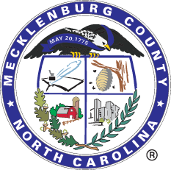

Mecklenburg County, North Carolina

Procurement Division

Solicitation # 487-BL-CAO004004

**RFP for** **Sketch Verification Tool**

Mecklenburg County, located in the State of North Carolina, is seeking proposals from qualified vendors to provide **proposals for a Property Appraisal Sketch Verification Tool** for the **County Assessor's Office**.

**The full solicitation can be viewed at** [**www.meckprocure.com**](http://www.meckprocure.com) **by clicking “View Published Solicitations” on the screen.**

**RFP DUE DATE:** No later than 2:00 PM (EST) on Friday, April 18, 2025.

**RFP NUMBER:** 487-BL-CAO004004

**RFP ACCEPTANCE PLACE:** All responses **must** be submitted by the Due Date via [MECKProcure.](http://www.meckprocure.com/)

Vendors must have a profile with the County to submit a response. For more information on vendor registration and how to submit a response, please visit the Vendor Resources Site [here](https://www.mecknc.gov/Finance/Procurement/Pages/Instructions-and-Forms.aspx).

Please note that all updates regarding this solicitation will be posted on the above-mentioned website, [MECKProcure.](http://www.meckprocure.com/)  To ensure that notifications are received, vendors must create a profile with the County.

If you are a registered vendor with the County and did not receive an email notification about this solicitation, please update your vendor profile to include the NIGP Code(s) listed below so that you receive notice of future business opportunities.

**NIGP Code(s):** 96859, 20977, 20876, 94615, 57863, 96866, 94616 and 91814

Sincerely,

Brian Lowman

Procurement Analyst

[Brian.Lowman@MecklenburgCountyNC.gov](mailto:Brian.Lowman@MECKLENBURGCOUNTYNC.GOV)