Request for Proposals
Cameron Dewberry Barn – Site Preparation Services
Release date: October 3, 2024
Proposal due date: October 31, 2024 – 5:00 p.m.
Submit completed proposal packets to:
Lindsay Whitson
Community and Economic Development Director – Central Pines Regional Council
lwhitson@centralpinesnc.gov

- Overview of Request for Proposals (RFP)

The Town of Cameron, located in Moore County, North Carolina, is seeking a qualified individual or firm to provide site preparation services. This may include erosion control, site prep, storm drainage, curb and gutter, among other related services. Services will be provided on the newly acquired 6.05-acre lot (parcel ID #20060706) next to the town-owned Phillips Memorial Park. The site will be the future home of the Dewberry Barn, which will be a municipal event space for baby showers, graduation parties, antique showings, among other uses. A survey of the property and soil testing has already been completed and can be provided upon request. Images of the parcel are provided below.

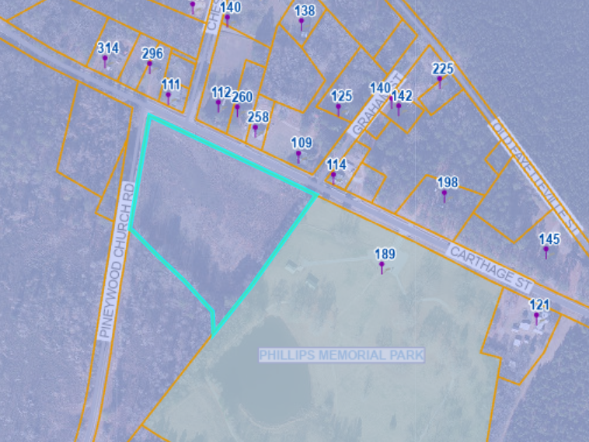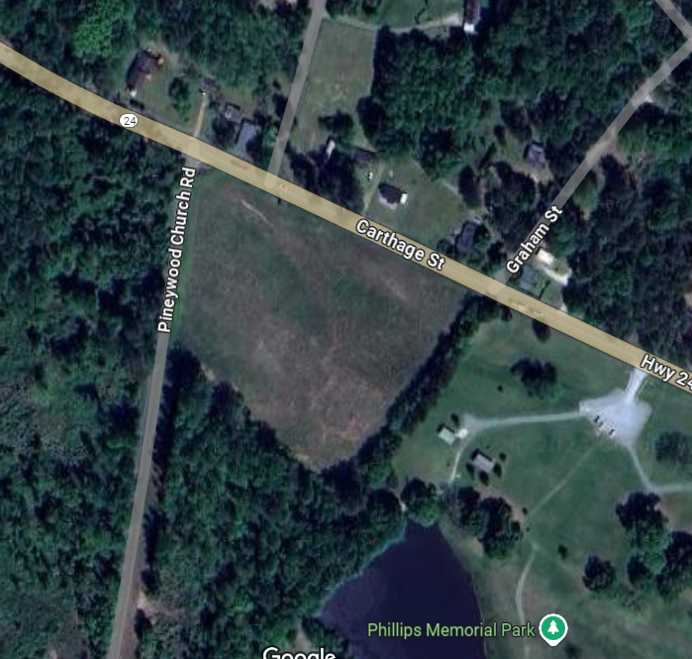

- Project Timeline

Release Date of RFP | October 3, 2024
Deadline for RFP Questions | October 18, 2024
Deadline for Complete Proposals | October 31, 224
Select Contractor and Negotiate Contract | November 15, 2024
Anticipated Completion of Site Preparation Services | December 31, 2024

- Proposal Format

Proposals should include the following:
- Team qualification and key personnel: Assessment of the capabilities of the individuals that will be engaged in the project. Qualities and indicators that will receive consideration include what professionals will be doing/working on each task; the various professional, technical, and educational achievements and registrations of each organization and individuals involved; the applicable experience of the proposed assigned staff, and the specific experience gained on similar projects. This should also include the proposal contact and their contact information.
- Proposed work and timeline: The Town is striving to have all site preparation services completed no later than December 31, 2024. There is some flexibility allowed, and we understand that things like weather cannot be controlled, but higher points will be given to submittals that anticipate being able to meet this timeline.
- Project experience and references: Include the names of three individuals that can be contacted as references concerning the professional capabilities and resources of your services and/or firm. Please describe three projects where you have completed similar services over the past seven years. If you have experience working with federal funding programs, include at least one example.
- Inclusion of an innovative approach and identification of ways to address cost-efficiency. Include any ways that you believe you may be able to offer cost-efficiency with execution of the work.

- Proposal Evaluation
The Town of Cameron will select an individual or firm through a competitive process based on the submitted deliverables identified above in Section III.

- Questions and Submittal:
To ensure consistent response and correct information to all interested parties, potential respondents must submit all questions and requests for clarification in writing to Lindsay Whitson, lwhitson@centralpinesnc.gov. All questions must be submitted by 5:00pm EST on October 18, 2024 to receive a response in advance of the solicitation closing. An addendum will be provided showing official responses to all questions submitted. Responses will be provided by 5:00pm EST on October 22, 2024 on the Town of Cameron’s website. All proposals must be submitted digitally to Lindsay Whitson, lwhitson@centralpinesnc.gov with a formatted email title that says: Town of Cameron – “Submitting Organization’s Name” by 5:00 p.m. EST on October 31, 2024 to be considered for this project opportunity.

- Conditions, Clarifications, and Reservations:
- The Town reserves the sole discretion and right to reject any and all responses received with respect to the RFP and to cancel the RFP process at any time prior to entering into a formal agreement. The Town further reserves the right to request additional information or clarification of information provided in any response. The Town also reserves the right, but is under no obligation, to waive technicalities and informalities. The Town shall make the award as deemed in its best interest.
- A response to this RFP should not be construed as a contract, nor indicate a commitment of any kind. The RFP does not commit the Town to pay for costs incurred in the submission of a response to this RFP or for any cost incurred prior to the execution of a final contract. No recommendations or conclusions from this RFP process concerning an individual firm shall constitute a right (property or otherwise) under the Constitution of the United States or under the Constitution, case law or statutory law of North Carolina. Neither binding contract, obligation to negotiate, nor any other obligation shall be created on the part of the Town unless the Town and you and/or your firm execute a contract.
- All responses to this RFP shall be the property of the Town.

