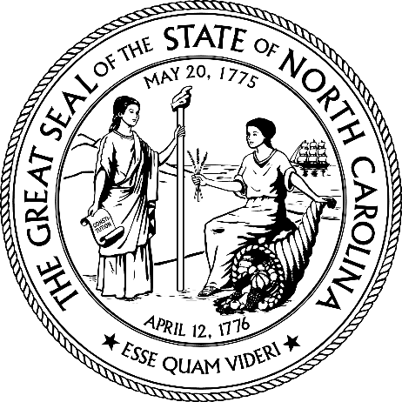

SOLCITATION ADDENDUM

Issuing Agency: | NCDAC
Solicitation Number: | 52-IFB-1404105941-MLE
Solicitation Description: | Navy Poplin Fabric-Tabor Sewing Plant
Solicitation Opening Date and Time: | January 29, 2024, at 2:00 PM
Addendum Number: | 01
Addendum Date: | 12/23/2024
Purchasing Agent: | Lorraine Middleton

FAILURE TO RETURN THIS ADDENDUM MAY SUBJECT YOUR RESPONSE TO REJECTION.

- The Solicitation is hereby modified as follows:

 | Modification # | Solicitation Section | Current Solicitation Language | Updated Solicitation Language
1 |  | 2.4 IFB SCHEDULE |  | Microsoft Teams Need help?  Join the meeting now  Meeting ID: 229 026 063 852  Passcode: nh9Zn3gT  Dial in by phone  +1 984-204-1487,,458192030# United States, Raleigh  Find a local number  Phone conference ID: 458 192 030#  Join on a video conferencing device  Tenant key: ncgov@m.webex.com  Video ID: 111 889 390 8  More info  For organizers: Meeting options | Reset dial-in PIN
2 |  | 4.10 SAMPLES | SAMPLES NEED TO BE SENT IN BEFORE THE BID OPENS ON: 1/xx/2025 @ 2:00 PM. | SAMPLES NEED TO BE SENT IN BEFORE THE BID OPENS ON: 1/29/2025 @ 2:00 PM.

- The following are questions received about the Solicitation and the State’s response to those questions:

Question # | Document Section | Vendor Question | State’s Response

Check ONLY ONE of the following options and return one properly executed copy of this Addendum prior to the Solicitation opening time and date.

☐ A response was submitted prior to this Addendum. An updated response has been submitted to address the changes resulting from this Addendum.

☐ A response was submitted prior to this Addendum. NO CHANGES have resulted from this Addendum.

☐ A response was not submitted prior to this Addendum. ANY CHANGES resulting from this Addendum are included in our response.

ALL OTHER TERMS AND CONDITIONS REMAIN THE SAME

_________________________________________ _______________________________
Authorized Signature Date

_________________________________________ _______________________________
Printed Name Title

