

Appendix E: CAD Interfaces List

RFP #354-PD25-34
Project Title: Computer Aided Dispatch (CAD) System Replacement

CAD Interfaces Context Model

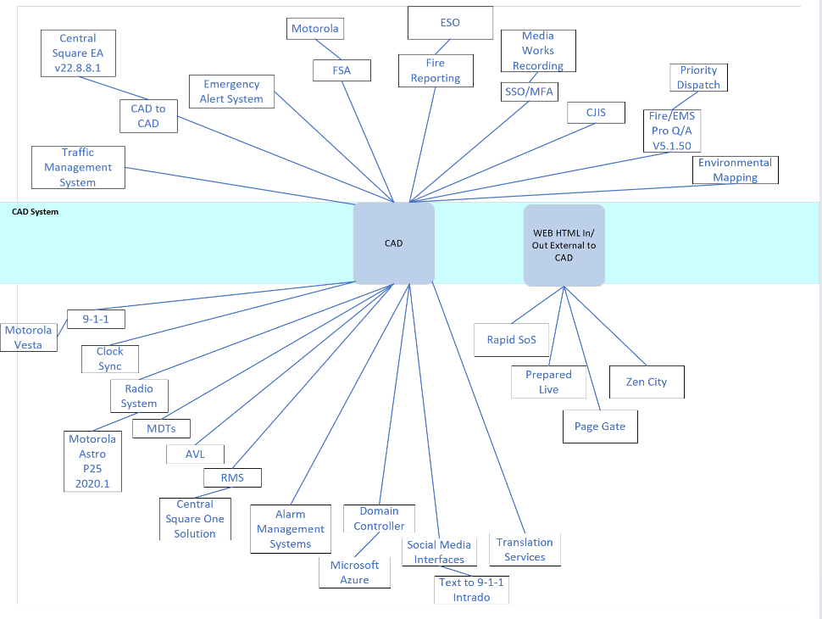

CAD Interfaces List
Interface Name | Exchange Type | Mechanism
GIS/ESRI | Flat file | SFTP/Portable Media  à Push  ß In
CAD-to-CAD | Exe file | Bi-Directional with Raleigh runs .exe
Traffic Management System | N/A | No Current functionality but looking for proposed vendor functionality
Emergency Alert System | N/A | No Current functionality but looking for proposed vendor functionality
Fire Station Alerting (FSA) Motorola | Radio system | This is done through the radio system.
Fire Reporting-ESO | XML file | Windows Service Generates XML file.
SSO/MFA | SAML | Okta is used for both
CJIS | SAML | No services. compliance
Pro Q/A Priority Dispatch | Exe file | Runs on server accelerator running on .exe
Environmental Mapping | Exe file | No Current functionality but looking for proposed vendor functionality
9-1-1 System | ANIALI .exe | ANIALI .exe on server
Clock Sync | log files | Time Service NTP
Radio System | PST files | PSServices
MDTs | exe file | Application runs .exe file
AVL | Secure files | Windows Service
RMS | .exe file | Application runs .exe file
Alarm Management Systems | ORI file | Asap to psap NCIC ORI
Domain Controller | Secure files | Integrates with OKTA
Social media-Text to 9-1-1 | N/A | Phone system
Translation Services | N/A | Done through phone call no integration

