BIDDING QUESTIONS - CENTRAL PENDER PARK: PHASE 1 PROJECT

Updated: November 13, 2024

- 1. Is a concrete duct bank required for all site conduits or just feeders?
“See Section 260543-3.01 for underground duct application”

- Who is the Pender County approved vendor for the camera and access control per E201?
Pender county does not have approved vendors for camera and access control, we only have vendors we have previously used and they are, https://encoretg.com/ , https://nitorsi.com/ , https://www.basllco.com/contact

- Who is the electrical utility company?
It is Four County Electric Membership Corp https://www.fourcty.org/.

- Can you let me know who submitted bids at the November 5th bid opening?
We did not have enough to open so all bids were rejected.

Date: October 28, 2024

- Q1: Can a bidding Prime Contractor count the work they would self-perform as part of the 10% MWBE goal, or does it need to be different companies to meet that 10%?
A: If the bidding Prime Contractor is a MWBE or HUB, the self-performed work would count toward the 10%. Just to clarify, the 10% is a genuine goal, but not a requirement.

Q2: How can the landscape contractor warranty plant material in areas that are not planned to be irrigated and have no way to hand water to establish?
A: The subcontractor will not be held liable for areas not indicated to have irrigation. If the construction firm wants to insert a hold harmless clause such as the one below, I think it might sway their bidding opinion maybe.
“Hold Harmless and Indemnification Clause
The Contractor shall not be held liable for any damages, loss, or injury resulting from, or related to, areas of landscaping not covered or serviced by the irrigation system installed by the Contractor. The Client acknowledges that the irrigation system is designed to cover specific areas as outlined in the project plan, and any areas not covered by the irrigation system are excluded from the Contractor’s responsibility.
The Client agrees to indemnify, defend, and hold harmless the Contractor, its officers, employees, and subcontractors from and against any and all claims, demands, damages, losses, costs, or expenses, including attorney's fees, arising out of or in connection with any damage or loss to areas not covered by the irrigation system.
This clause applies to any claims for damage or deterioration of landscaping, plant health, or other related issues in areas not directly serviced by the irrigation system”.

Q3: Is the County open to approving as “equal” a 2nd manufacturer for the 2 bleachers w/ ADA spaces and guardrail?
A: Yes, “approved equals”, with accompanying specification sheets for review, will be accepted for materials called out in the Bid Documents.

Q4: Page A2 of the drawings indicate a “Optional Louvered Penthouse”, I did not see where this was an alternate. Are we to include the penthouse in the base bid of the project?
A: Owner has opted not to include the Louvered Penthouse in the construction or as an alternate for bidding.

Q5: Appliances – Are the appliances to be supplied by the Owner or Contractor? Who will be in charge of installation?
A: The owner will provide the freezer and ice machine, contractor quotes the remaining appliances (popcorn machine, hotdog machine, x1 refrigerator, x2 glass door refrigerators. Owner will deliver freezer and ice machine and coordinate installation with contractor.

- Q6: Pick-Up Window Countertop – What material is this? Could we be provided a detail? A: Material should be Corian for the pick-up window counter top. See image below for window countertop.
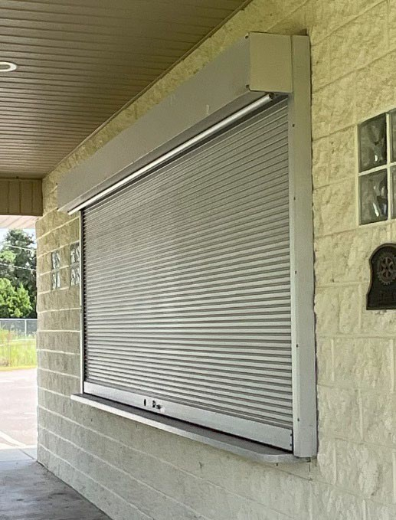

Q7a: Millwork: P-002 indicates the LAV-1 as a counter mounted lavatory, however we are not seeing any detail to how these countertops are constructed and materials?

A: Please view attached image of lavatory countertop build.

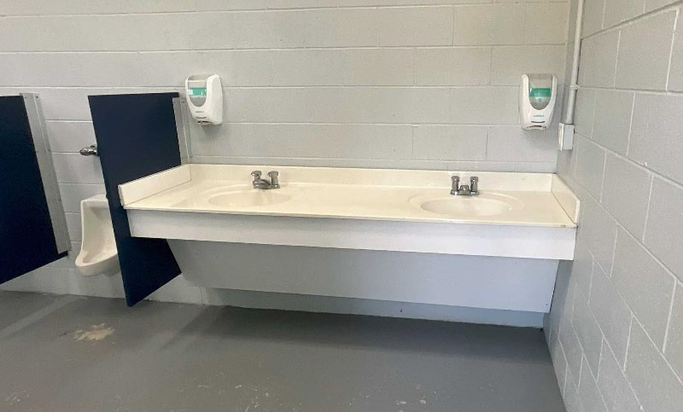
Q7b: There appears to be millwork in the Serving Area and shelving in the Concession Storage, can you provide a detail for these, or are these by Owner?
A: Please view images of serving area, all tables are stainless steel/ restaurant grade to be quoted by contractor. Concessions storage shelving will be provided by the owner.
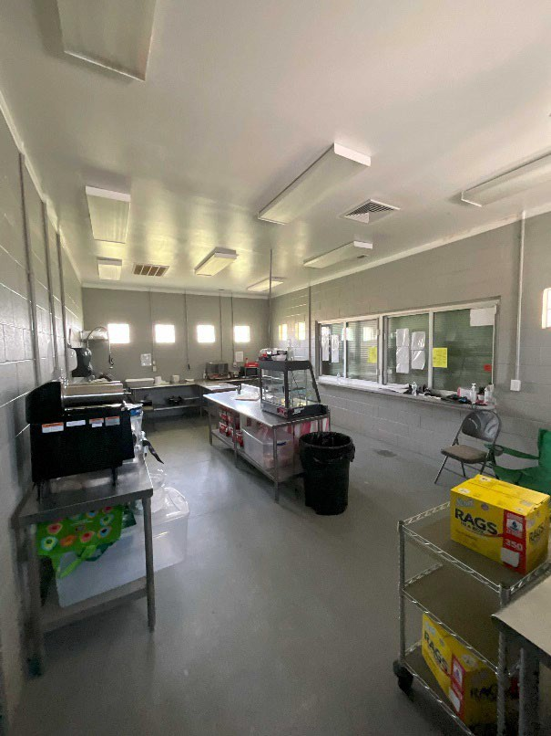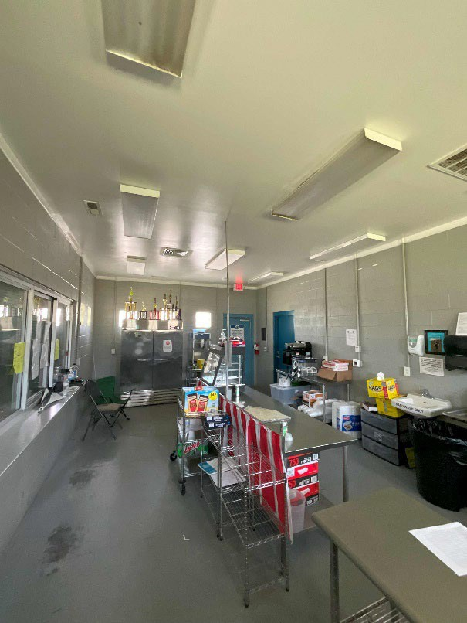

Q8: Doors/Frames/Hardware – There doesn’t seem to be any specifications for these or elevation details. Would it be possible to provide a door and window legend for clarification?
A: Please view images for reference, general details are: Opening Size (WxH) 3’-0”x7’-0”, metal door material, hollow metal door frame.
General Notes:
ALL DOORS AND ASSOCIATED HARDWARE WITHIN SCOPE OF WORK AREA ARE TO COMPLY WITH CHAPTER 4 OF ICC ANSI A117.1.
ALL NEW DOORS SHALL RECEIVE NEW MORTISE LOCKSETS. GC TO COORDINATE WITH BUILDING OWNER. LEVER/ROSE STYLE TO BE BUILDING STANDARD HARDWARE (GC TO VERIFY W/ OWNER). ALL HARDWARE TO HAVE 626 (US26D) SATIN CHROME FINISH.
GC SHALL BE RESPONSIBLE FOR SUPPLYING AND INSTALLING ALL BUILDING SYSTEM KEYED LOCKS PER BUILDING OWNER KEYING SYSTEM. COORDINATE EXACT REQUIREMENTS WITH BUILDING OWNER/OCCUPANT.
PROVIDE DOOR SILENCERS TYP. AT ALL DOORS. PRE-DRILL FRAMES FOR (3) JAMB SILENCERS AND (2) HEAD SILENCERS FOR DOORS UNDER 8' TALL.
COMPLETE MANUFACTURER DOOR AND HARDWARE SCHEDULE SHALL BE PROVIDED BY GENERAL CONTRACTOR FOR ARCHITECT REVIEW AND APPROVAL
ALL DOORS AND FRAMES SHALL BE PRE-MACHINED FOR FINISH HARDWARE, INCLUDING ELECTRIFIED HARDWARE
PROVIDE FLOOR STOPS AT ALL DOOR LOCATIONS (626 FINISH) W/ GRAY RUBBER BUMPERS. PROVIDE OVERHEAD STOPS AS SPECIFIED IN DOOR SCHEDULE.
WHERE NEEDED, CONCEALED OVERHEAD CLOSERS SHALL BE EQUAL TO DORMA RTS 88 SERIES. UNO, WHERE NEEDED, SURFACE MOUNTED CLOSERS SHALL BE EQUAL TO LCN4010/4110.
ALL LOCKSETS TO BE KEYED MUST GO THROUGH OWNER'S VENDOR. GC SHALL COORDINATE W/ OWNER AS REQUIRED.

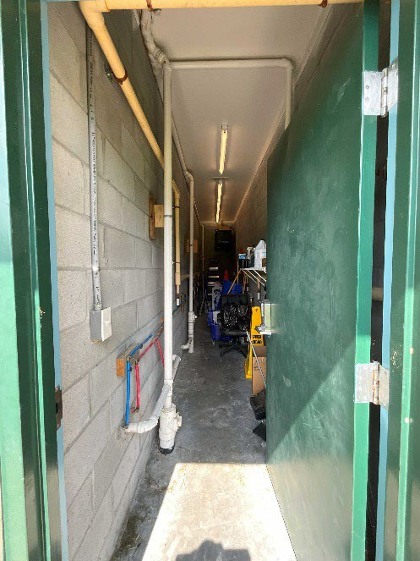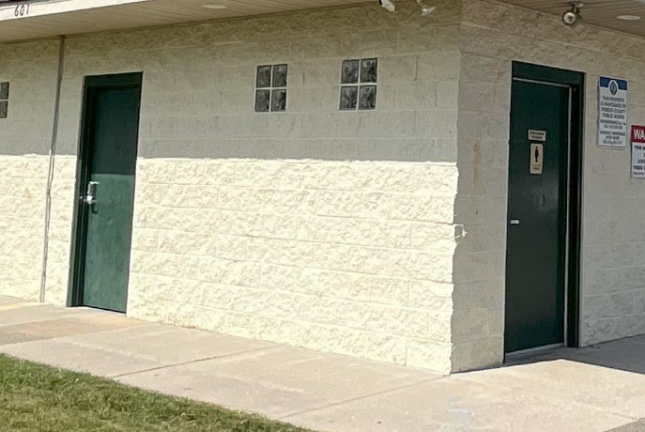

Q9: Toilet Accessories & Toilet Partitions – There doesn’t seem to be any specifications for these.
A: Please see pictures for general lavatory partition and fixtures.
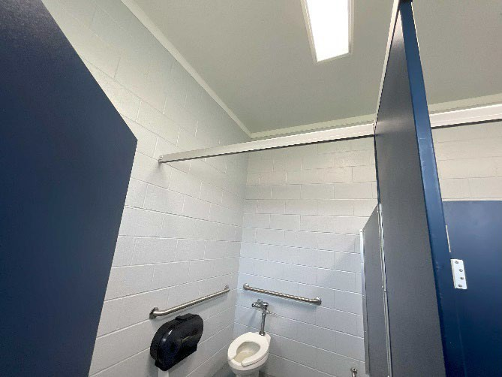
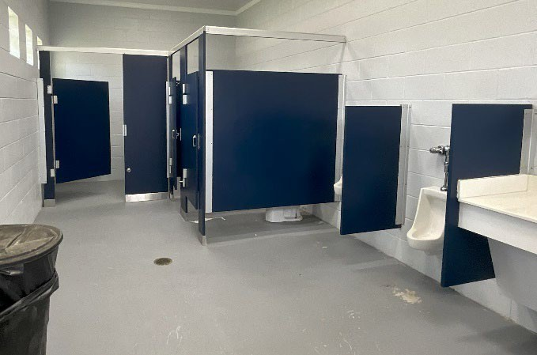

Q10: Page A2 identifies the flooring as Epoxy coating with 4” rubber base. Is this detail to carry through all rooms? Would it be possible to provide a room legend for clarification?
A: Affirmative on the epoxy coating through all rooms. Negative on the 4” rubber base – material not required to be installed.

If you need further information, please contact Dario Ramirez-Duenas or Trisha Newton at dramirezduenas@pendercountync.gov, or tnewton@pendercountync.gov, or call 910-259-1281.

Dario Ramirez-Duenas
Pender County Project Manager

