

Town of Garland

Request for Proposal #:
G-2026-005
Cain Memorial Park Bathroom
Located at 121 S. Bladen Avenue

Date of Issue: January 30, 2026

Proposal Opening Date: February 13, 2026, at 10:30 AM

Direct all inquiries concerning this RFP to:
Samantha Hobbs
Town Clerk
Email: town.clerk@townofgarland.com
Phone: 919-529-4141

To Whom It May Concern:

On behalf of the Town of Garland, I am pleased to submit this Request for Proposals (RFP) for projects funded through the Community Development Block Grant (CDBG) program, aimed at improving parks and recreation facilities throughout our community.

The Town seeks qualified consultants/firms to assist with the planning, design, and implementation of enhancements to our parks and recreational spaces. These improvements will promote community engagement, accessibility, and quality of life for residents.

Interested firms are encouraged to review the RFP and submit proposals in accordance with the instructions provided.

The Town looks forward to partnering with professionals who can help bring these projects to successful completion.

For questions or additional information regarding this RFP, please contact Samantha Hobbs, Town Clerk at 919-529-4141 or town.clerk@townofgarland.com.

Sincerely,

Ralph Smith, Jr.

Mayor, Town of Garland

PURPOSE
The Town of Garland is seeking proposals from qualified contractors to construct and pave a walking track located at the West 7th Street Soccer Field. This project is funded through Community Development Block Grant – Neighborhood Revitalization (CDBG-NR) funds under Grant Number 20-D-3060 (NR), a companion grant to 18-C-3060. All funds associated with this project must be fully requisitioned by August 13, 2026.

The purpose of this Request for Proposals is to solicit qualified contractors to construct a new public restroom and storage building at Curtis Cain Memorial Park. The project is intended to provide an accessible, code-compliant restroom facility and secure storage space to support park operations and public use. The selected contractor shall deliver a complete, turnkey building suitable for long-term municipal use.

This project is funded in whole or in part by Community Development Block Grant – Rural Economic Development Division (CDBG REDD) funds and is subject to all applicable Federal and State requirements, including 2 CFR Part 200. The Town will conduct this procurement in a manner providing full and open competition and without geographic preference.

All work must be performed in accordance with applicable local, State, and Federal regulations, including CDBG-NR requirements and 2 CFR Part 200. Contractors are responsible for ensuring compliance with any applicable environmental or regulatory constraints.

The Town anticipates issuing this RFP in early 2026 with selection and award targeted for mid-February 2026. Construction is expected to be completed within a timeframe that allows all grant funds to be fully expended and requisitioned no later than August 13, 2026.



SCOPE of WORK
The contractor shall furnish all labor, materials, equipment, permits, and incidentals necessary for the construction of a new restroom and storage building at Curtis Cain Memorial Park.

Building Construction
- Construct a new building approximately 16 feet by 10 feet on a concrete slab foundation.
- Exterior walls shall be constructed of concrete block with brick veneer or comparable durable materials suitable for public park facilities.
- Interior walls shall be constructed of concrete block, minimum 8 inches thick or equivalent.

Restroom Facilities
- Provide one ADA-accessible restroom, constructed in compliance with applicable building codes and accessibility requirements.
- Restroom shall include:
  - Accessible plumbing fixtures
  - Hand dryer
  - Mechanical ventilation or heat fan installed in the ceiling
  - Lighting and electrical systems suitable for public use

Storage Area
- Provide a secure storage room within the building for park maintenance and operations.
- Storage area shall include durable finishes suitable for utility use.

Doors, Mechanical, and Electrical
- Install two exterior steel doors on the front of the building, including appropriate hardware and locks.
- Provide all required electrical, plumbing, and mechanical systems necessary for a fully operational facility.
- Contractor shall coordinate utility connections as required.

General Requirements
- All work shall comply with applicable local, state, and federal codes and standards.
- Contractor shall obtain all required permits and inspections unless otherwise directed by the Town.
- Site shall be restored to equal or better condition upon completion.
- Contractor shall provide warranties for workmanship and materials.
- Final inspection and acceptance shall occur prior to project closeout.

PROJECT LOCATION MAP
121 S. Bladen Avenue Garland, NC 28441

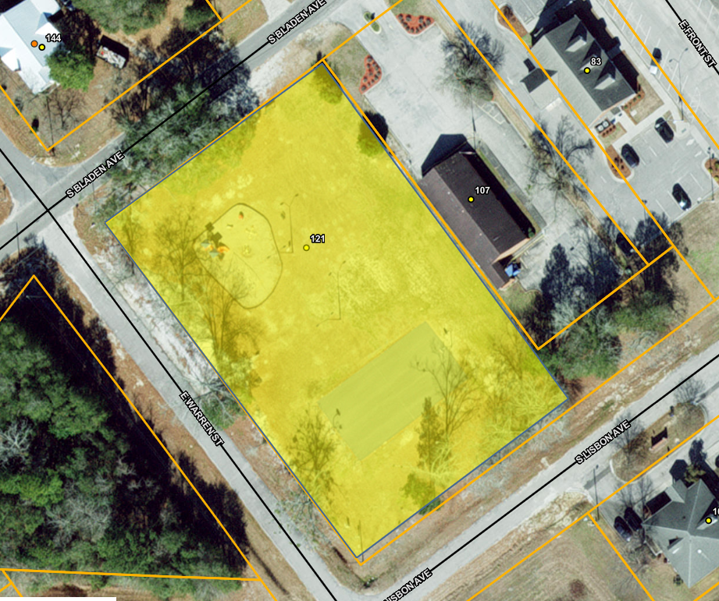

PROPOSAL SUBMISSION (NC eVP Ready)
Proposals must be submitted electronically through the North Carolina eProcurement (eVP) system by:
Date: February 13, 2026
Time: 10:00AM

All proposal responses shall be submitted electronically via the electronic Vendor Portal (eVP). Additional information can be found at the eVP updates for Vendors link: https://eprocurement.nc.gov/news-events/evp-updates-vendors

Late proposals will not be accepted.

RFP PROJECT SCHEDULE
The Town anticipates the following general schedule:

Event | Responsibility | Date and Time
Issue RFP | Town | January 30, 2026
Pre-Proposal Meeting/Site Visit | Town | February 5, 2026, 10:00AM
Submit Written Questions | Vendor | February 6, 2026, 10:00AM
Provide Responses to Questions | Town | February 11, 2026, 10:00AM
Submit Proposals | Vendor | February, 13, 2026 10:00AM
Bid Opening | Town | February 13, 2026, 10:30AM
Contract Award | Town | Mid-February 2026

PROPOSAL QUESTIONS
Upon review of the RFP document, Vendors may have questions to clarify or interpret the RFP in order to submit the best proposal possible. To accommodate the Proposal Questions process, Vendors shall submit any such questions by the “Submit Written Questions” date and time provided in the RFP Project Schedule section above, unless modified by addendum.

Written questions shall be emailed to town.clerk@townofgarland.com by the date and time specified above. Vendors should enter the RFP number as the subject for the email. Question submittals should include a reference to the applicable RFP section and be submitted in the format shown below:
Reference | Vendor Question
RFP Section, Page Number | Vendor question….?

CONTRACT TERM
The contract resulting from this RFP shall commence upon final execution by all parties. Work shall begin within five (5) business days of the Town’s issuance of a written Notice to Proceed.

The initial contract term shall be one hundred eighty (180) calendar days from the Notice to Proceed. All work must be completed, accepted, and fully requisitioned no later than August 13, 2026, in accordance with CDBG-NR Grant Number 20-D-3060 (NR).

EVALUATION CRITERIA and SELECTION PROCESS
Only responsive submissions will be evaluated.

Proposals will be evaluated and scored according to the following criteria:

Criteria | Points
Cost/Price Reasonableness | 40
Experience with Similar Projects | 20
Project Approach & Schedule | 20
Compliance with RFP Requirements | 10
References | 10
Total | 100

The awarded contractor must comply with all applicable Federal requirements, including but not limited to:
- 2 CFR Part 200
- Debarment and Suspension (SAM.gov verification required)
- Access to Records
- Equal Employment Opportunity
- Termination for Cause and Convenience
- Contract Work Hours and Safety Standards Act (if applicable)

Schedule & Grant Deadline
All work must be completed and all CDBG REDD funds expended no later than August 13, 2026.

AWARD OF PROPOSAL
Presentations may be requested of two or more bidders deemed by Town to be the best suited among those submitting proposals on the basis of the selection criteria. After presentations have been conducted, Town may select the bidder which, in its opinion, has made the proposal that is the most responsive and most responsible and may award the contract to that bidder. Town may cancel this RFP or reject any or all proposals in whole or in part. Should Town determine in its sole discretion that only one bidder is fully qualified, or that one bidder is clearly more qualified than any other under consideration, a contract may be awarded to that bidder without further action.

CONFIDENTIALITY
The information contained in proposals submitted for consideration will be held in confidence only as permitted by public records laws until all evaluations are concluded and an award has been made. Pricing and other information that is an integral part of the offer cannot be considered confidential after an award has been made.

PROPOSAL INFORMATION
The Bidder shall provide, at minimum, the following information in the proposal:

Project Cost

Project Summary – Provide detailed summary of how the bidder will approach the project scope. Include information pertaining to project timeline and methodology of data collection.

Location – Provide the physical and mailing address of the bidder.

References – Provide a list of three references. These references should be organizations that the bidder has done business with during the timeframe of January 2022 through present date.

ATTACHMENTS
Complete and return the Customer Reference Form, which can be found at the following link:
https://ncadmin.nc.gov/media/15503/open

Complete, sign, and return the Certification of Financial Condition, which can be found at the following link:
https://www.doa.nc.gov/pandc/onlineforms/pc-certification-financial-condition-92021-pdf/open

CONTRACT PROVISIONS
Contractor must provide and maintain any licenses and permits required of the Town, County, State and Federal Government, as well as any other requirements of the law.

Contractor hereby identifies and will not hold the Town, its agents, and the property hold harmless, and shall defend them against any and all action, claim and cost resulting by the negligence of the Contractor, its agents and/or employees. Contractor will not be held responsible for any acts of God (Ice, Freezing, Hurricanes, storms, Floods, or uncontrollable infestations of diseases and/or insects.

Contractor with permission from the Owner in written permission form of approval reserves the right to hire qualified Subcontractors to perform specialized functions or work requiring such and/or specialized equipment.

Either party may cancel this agreement by giving written notice of thirty (30) days at any time during the term of the contract.

A monthly invoice for work performed must be presented and shall reflect what scope of work was performed for that billing period per site.

CONTRACT MANAGER
The Vendor shall be required to designate and make available to the State a contract manager. The contract manager shall be the State’s point of contact for Contract related issues and issues concerning performance, progress review, scheduling, and service.
Contract Manager Point of Contact
Name:
Office Phone #:
Mobile Phone #:
Email:

