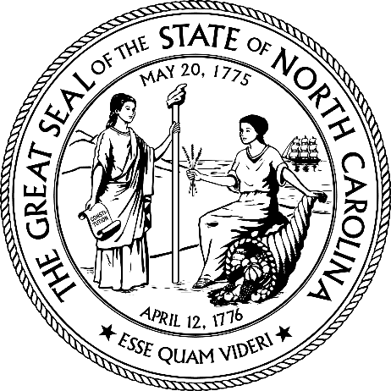

SOLCITATION ADDENDUM

Issuing Agency: | North Carolina Department of Public Instruction
Solicitation Number: | 24-RQ140038-KR
Solicitation Description: | 2024-2025 Fuel Truck(s) Replacement
Solicitation Opening Date and Time: | November 29, 2024 by 10:00 AM ET  December 5, 2024 by 9:30 AM ET
Addendum Number: | 1
Addendum Date: | 11/14/2024
Purchasing Agent: | Krystle Rice

THIS ADDENDUM IS NOT REQUIRE TO BE RETURNED WITH THE BID SUBMISSION

- The Solicitation intended IFB schedule is hereby modified as follows:
Modifications to schedule are in red and language that is removed is stricken.

2.4 IFB SCHEDULE
The table below shows the intended schedule for this IFB. The State will make every effort to adhere to this schedule.
Event | Responsibility | Date and Time
Issue IFB | State | November 8, 2024 November 14, 2024
Submit Written Questions | Vendor | November 14, 2024 November 21, 2024 by 10:00 AM ET
Provide Responses to Questions | State | November 20, 2024 November 23, 2024
Submit Bids | Vendor | November 29, 2024 by 10:00 AM ET  December 5, 2024 by 9:30 AM ET  Public bid opening for this solicitation will be conducted via conference call.  Vendor may use the kinks or call-in number below to join the bid opening scheduled for:  Microsoft Teams Need help?  Join the meeting now  Meeting ID: 285 043 012 14  Passcode: 8oKUHE  Dial in by phone  +1 919-230-4058,,31952871# United States, Cary  Find a local number  Phone conference ID: 319 528 71#  For organizers: Meeting options | Reset dial-in PIN

ALL OTHER TERMS AND CONDITIONS REMAIN THE SAME

